CQUniversity Australia
COIT20265 - Networks and Information Security
Assessment 3 - Project Progress Final Report

An NLP-Based Prototype for Anomaly Detection in
Cloud-Generated and Benchmark Cybersecurity Logs
LogGuard AI

Team Member | Student ID | Role | Primary Contributions
Tahmid | [Student ID] | Project Manager | Project planning, stakeholder liaison, report writing, coordination
Mahin | [Student ID] | Cloud Engineer | AWS infrastructure, website, LSTM model, Streamlit dashboard
Nafisa Sultana | [Student ID] | Software Engineer | System integration, API design, component architecture
Yeakub | [Student ID] | Data Analyst / NLP Developer | Dataset collection, Random Forest, data preprocessing, visualisations

Project Client: Dr Fariza Sabrina
Supervisor: Dr Fariza Sabrina | CQUniversity Australia
Submission: Exam Week - May 2026

Abstract
This report encompasses the complete lifecycle document of a prototype system, LogGuard AI, an NLP-based system that is destined to identify anomalies in cloud-generated and benchmark cybersecurity logs, as the final project deliverable of the COIT20265 capstone project. The team that designed the system at CQUniversity Australia comprised four people and was headed by Dr Fariza Sabrina.
The prototype is composed of four machine learning and deep learning models, i.e. Random Forest, Isolation Forest, LogBERT and Bidirectional LSTM, which were trained on a multi-source dataset of 7,254 log entries of benchmark repositories and a running AWS EC2 instance. The prototype is deployed on Amazon Web Services with the assistance of a nine-stage pipeline consisting of an S3-hosted website, API Gateway, Lambda, CloudWatch, EC2, SNS, S3 alert storage, and a Streamlit dashboard.
F1-Score and Recall of the bidirectional LSTM model were 0.9987 and 1.0000, respectively on the test set. The F1 and ROC-AUC of the Random Forest baseline were 0.9971 and 1.0000, respectively. It is known that such results are partly influenced by the data labelling with the help of keywords, which is mentioned as the primary drawback. The prototype uses the key elements of the detection pipeline and shows end-to-end alerting via structured LogBERT output, but automated translation between live CloudWatch logs into the EC2 LogBERT processor will be future work.
This report represents the background of the project, the needs of the stakeholders, the system design choices, technical artefacts, the ethical concerns, the project management processes, the performance assessment and future development plan based on the COIT20265 Assessment 3 requirements.

Table of Contents
Abstract i
1. Project Overview and Problem Definition 1
1.1 Background 1
1.2 Problem Statement 1
1.3 Project Objectives 1
1.4 Project Scope 1
1.5 Stakeholder Overview 2
1.6 Requirements and Design Decisions 2
1.6.1 Initial Requirements 2
1.6.2 How Requirements Evolved 3
2. Literature Review - NLP in Cybersecurity 4
2.1 Evolution of Log-Based Anomaly Detection 4
2.2 BERT and Transformer Models for Log Analysis 4
2.3 LSTM for Sequential Log Analysis 4
2.4 Traditional Machine Learning Baselines 4
2.5 Comparative Analysis of Prior Studies 5
2.6 Cloud-Based Log Management and AWS Integration 5
3. System Architecture 6
3.1 Layered System Architecture 6
3.2 Nine-Stage Pipeline 8
3.3 Technology Stack 9
4. Dataset 10
4.1 Dataset Overview 10
5. Data Preprocessing 12
5.1 Preprocessing Pipeline Overview 12
5.2 Labelling Strategy and Data Leakage Acknowledgement 13
6. Algorithms and Models 14
6.1 Random Forest 14
6.2 Isolation Forest 15
6.3 LogBERT 16
6.4 Bidirectional LSTM 16
6.5 Algorithm Comparison 19
Supervised and Unsupervised Models - Binary Classification Metrics 19
LogBERT - Self-Supervised Model (Reconstruction Loss Protocol) 19
7. AWS Cloud Integration Pipeline 20
7.1 Pipeline Overview 20
7.2 Stage 1 - Static Website Hosted on Amazon S3 21
7.3 Stage 2 - Website Event Logging 21
7.4 Stage 3 - API Gateway and Lambda Log Receiver 22
7.5 Stage 4 - Website Logs Stored in CloudWatch 23
7.6 Stage 5 - EC2 LogBERT Processing Environment 24
7.7 Stage 6 - LogBERT Anomaly Results as Structured JSON 25
7.8 Stage 7 - SNS Email Alerting with OpenAI Recommendations 26
7.9 Stage 8 - CloudWatch to S3 Storage 29
7.10 Stage 9 - Streamlit Dashboard 30
8. Website Development 30
8.1 Overview 30
8.2 Website Sections 31
8.3 Login Security Event Logging 31
9. Streamlit Dashboard 31
9.1 Architecture and Features 31
9.2 Integration with Anomaly Algorithm 32
10. Evaluation and Performance Analysis 32
10.1 Evaluation Methodology 32
10.2 Accuracy Results 33
10.3 Efficiency and Scalability Evaluation 33
10.4 Key Findings 34
Finding 1 - Recall is the Critical Security Metric 34
Finding 2 - Data Leakage Limits Scientific Claims 34
Finding 3 - Unsupervised vs Supervised Tradeoff 35
Finding 4 - LogBERT Requires Threshold Implementation 35
11. Ethical and Professional Considerations 35
11.1 Data Privacy and Consent 35
11.2 Security Responsibilities 35
11.3 AI Usage Transparency 36
11.4 Intellectual Property Considerations 36
11.5 Societal and Organisational Impact 36
12. Project Management Integration 37
12.1 Team Structure and Coordination 37
12.2 Work Breakdown Structure Summary 37
12.3 Risk Register 38
12.4 Change Management 39
12.5 Quality Assurance 39
12.6 Individual Contributions 39
13. Delivered Technical Artefacts 40
14. Limitations and Future Work 42
14.1 Current Limitations 42
Limitation 1 - Data Leakage from Keyword-Based Labelling 42
Limitation 2 - LogBERT Binary Classification Evaluation Incomplete 42
Limitation 3 - Live CloudWatch-to-EC2 Pipeline Pending 42
Limitation 4 - Small and Single-Environment Dataset 43
Limitation 5 - No GitHub Version Control 43
14.2 Future Work 43
Priority 1 - Complete Live CloudWatch-to-EC2 Connection 43
Priority 2 - LogBERT Binary Classification Output 43
Priority 3 - NIST Framework-Based Alert Recommendations 43
Priority 4 - GitHub Repository and CI/CD 43
15. Conclusion 43
16. References 45

1. Project Overview and Problem Definition

1.1 Background
Cloud computing infrastructure is a critical part of the day-to-day operations of modern organisations. A continuous stream of log data often containing vital information regarding system behaviour, user activity and security incidents is generated by cloud servers, web applications, authentication services and networked systems. Log data can signal security-related events such as intrusion attempts, unauthorised access, service failures, and more when properly analysed (Du et al. 2017).
There has been an exponential increase in the amount of log data within the cloud systems. The number of log entries by one cloud server can be thousands per hour. The manual inspection is not feasible, and the existence of rules as a detector creates a high false positive rate yet fails to identify sophisticated patterns of attack that are not represented by the existing signature(Chen et al. 2021). A promising solution is Natural Language Processing (NLP), where logs are considered text, which can be tokenised, vectorised, and run through language models, enabling it to detect significantly more effectively than traditional methods (Guo et al. 2021).

1.2 Problem Statement
There are three problems related to security teams in cloud environments. First, the amount of log data is very huge and cannot be analysed by human beings. Second, existing automated tools rely on manually authored rules that cannot be generalised to operate with other log formats, systems and types of attacks. Third, no single framework can unite live log collection, an anomaly detector powered by NLP, and real-time notifications into a single pipeline that can be deployed. All three issues will be overcome through the proposed project, which will model and establish LogGuard AI.

1.3 Project Objectives
The above problems are addressed by the project using three deliverables identified by the project client, Dr Fariza Sabrina:
- Prepare an in-depth research paper on NLP techniques and approaches that can be used in cybersecurity, analysis of the literature, challenges and opportunities.
- Develop a prototype tool of NLP based operational to analyse log files, detect abnormal activity, record development process and test the performance of the tool by carrying out wide tests.
- Conduct a detailed evaluation and a performance analysis using conventional metrics like Precision, Recall, F1-Score, ROC-AUC, False Positive Rate, efficiency and scalability.

1.4 Project Scope
The project deliverables are: multi-source log dataset collection/preprocessing; four NLP and machine learning model training/evaluation; full cloud deployment on AWS, which comprises S3 website hosting, API Gateway, Lambda, CloudWatch, EC2, SNS, and S3 alert storage; public-facing website with real-time log generation; and an interactive Streamlit dashboard. The system has an emphasis on SSH authentication logs, system logs, HDFS logs and cloud-produced event logs.

1.5 Stakeholder Overview
Stakeholder | Role | Interest / Expectation | Engagement Method
Dr Fariza Sabrina | Project Client & Supervisor | Technically rigorous prototype demonstrating NLP anomaly detection in cloud logs. Expects well-documented artefacts, evaluations, and professional reporting. | Weekly supervision meetings, milestone reviews, final report submission
CQUniversity Australia | Academic Institution | Successful completion of capstone project meeting COIT20265 learning outcomes including networking, security, and project management competencies. | Assessment submission via Moodle, grading against rubric
Project Team (4 members) | Developers & Authors | Gain practical experience in NLP, cloud computing, and security systems. Successfully complete the capstone unit with a high-distinction outcome. | Daily Kanban task management, group meetings, shared documentation
Security Administrators | End Users of Prototype | A system that accurately detects anomalous log activity with low false positive rate and provides actionable alert guidance with minimal false alarms. | Requirements informing system design; usability considered in dashboard design
Future Researchers | Academic Community | A well-documented baseline for NLP-based log anomaly detection that can be replicated, extended, and improved upon in future research. | Publication of dataset, code, and methodology in report

1.6 Requirements and Design Decisions

1.6.1 Initial Requirements
The initial project requirements, derived from the client brief and team analysis, were:
- The project requirements were initially formed based on the client brief and team analysis, nd they were:
- Functional Requirement 1 - The system should be able to ingest actual cybersecurity log data from multiple sources.
- Functional Requirement 2: The system will require NLP preprocessing to normalise the log text before it is input into the model.
- Functional Requirement 3: There will be at least two anomaly detection models which will be required to be trained and tested using the same data.
- Functional Requirement 4: When anomalies are identified to be over a configurable limit, the system has to generate real-time alerts.
- Visual Dashboard: The results of the detection must be presented in the form of a graphical dashboard and help security analysts in the decision-making process.
- Non-Functional Requirement 1: The system should be able to run on cloud-based infrastructure without any on-premises servers.
- Non-Functional Requirement 2: The system should be able to accommodate log formats of various sources without reconfiguring them manually.

1.6.2 How Requirements Evolved
The project lifecycle included requirements that were developed in three stages, consulted with stakeholders and analysed in terms of technical feasibility:

Phase | Trigger | Original Requirement | Evolved Requirement | Justification
Phase 1 (Weeks 1–2) | Client consultation | Analyse logs from one source | Collect from 5 sources (HDFS, OpenSSH, Linux, cloud_auth, cloud_syslog) | Dr Sabrina emphasised multi-source diversity for realistic evaluation
Phase 1 (Weeks 2–3) | Technical feasibility | Use one detection algorithm | Implement four models (RF, IF, LogBERT, LSTM) | Comparison of supervised, unsupervised, and self-supervised approaches was identified as academically stronger
Phase 2 (Weeks 3–5) | AWS account migration | Deploy on single AWS account | Migrate to new AWS account; implement API Gateway instead of EC2 direct posting | Original account was deactivated; API Gateway provided more secure log ingestion design
Phase 2 (Week 4) | Scope expansion | Static results dashboard | Live website with real-time CloudWatch log generation | Dr Sabrina requested a live demonstrable system rather than static evaluation only
Phase 3 (Weeks 6–7) | Technical limitation | Fully automated EC2-CloudWatch pipeline | EC2 LogBERT processes generated logs; live CloudWatch integration planned as future work | Technical complexity of live pipeline exceeded timeline; manual integration tested instead

Design Choice: The four-algorithm approach (RF + IF + LogBERT + LSTM) was chosen on purpose to compare the paradigms of supervised, unsupervised, and self-supervised - to directly address the requirements of the client in terms of strict evaluation and a more profound understanding of the technicalities.

2. Literature Review - NLP in Cybersecurity

2.1 Evolution of Log-Based Anomaly Detection
There are three generations of log-based anomaly detection. The first generation was founded on the idea of manually created rules and regular expressions that were only able to match familiar threat signatures and produced too many false positives when using different environments (Liu et al. 2008). The second generation employed statistical ML algorithms - PCA-based log clustering, k-nearest neighbours, and decision trees - which further improved generalisation at the cost of a large amount of feature engineering, which could not easily scale to unstructured log text (Pedregosa et al. 2011). Direct application of NLP to log text is used by the third generation and the current generation. Du et al. (2017) suggested DeepLog, an LSTM that treats log execution sequences as natural language and had significantly higher detection rates than the previous systems, setting the template for future research.

2.2 BERT and Transformer Models for Log Analysis
Devlin et al. (2019) suggested BERT (Bidirectional Encoder Representations from Transformers), which takes advantage of both directions of attention simultaneously, context-modelling needed in log analysis when the meaning of the tokens depends on the whole surrounding context. Guo et al. (2021) based their work on BERT, creating a BERT-adapted model, the first to detect log anomalies, named LogBERT. LogBERT is pre-trained with the normal log key sequences and shows windows with actual log keys at surprisingly low predicted probability. LogBERT was state-of-the-art on HDFS and BGL benchmarks and was significantly better than DeepLog and LogRobust.

2.3 LSTM for Sequential Log Analysis
Long Short-Term Memory (LSTM) networks were proposed by Hochreiter and Schmidhuber (1997), and they can acquire long-range dependencies by using three gating mechanisms. An extension is the bidirectional LSTMs that work on either side of sequences and produce richer representations that are particularly applicable in the context of log text, where context consists of both the preceding and succeeding tokens (Du et al. 2017). Bidirectional LSTMs are introduced as a complementary deep learning model to LogBERT and are used to detect log anomalies using word embeddings in place of log keys.

2.4 Traditional Machine Learning Baselines
Breiman (2001) suggested the Ensemble technique, Random Forest, which builds many decision trees based on bootstrapped samples. Random Forest with TF-IDF vectorisation (Salton and Buckley 1988) provides a supervised baseline that is interpretable and identifies the most predictive log terms in the classification of an anomaly. An unsupervised algorithm suggested by Liu et al. (2008) to detect anomalies based on ease of isolation in random feature splits, Isolation Forest, is useful when the labelled data is not available,e yet the contextual knowledge of NLP models is.

2.5 Comparative Analysis of Prior Studies
The following table summarises the main previous works in this regard, which will allow directly comparing data set, models, measures, and applicability:

Study | Model | Dataset | Key Metric | Advantage | Limitation | Relevance to LogGuard AI
Du et al. 2017 | DeepLog (LSTM) | HDFS, OpenStack | Precision=0.9616, Recall=0.9677 | First deep learning log anomaly detector; no labels needed at inference | Only captures sequential patterns; no semantic understanding | Directly inspires our LSTM implementation
Guo et al. 2021 | LogBERT | HDFS, BGL | HDFS: FPR<1%, BGL: FPR<5% | Bidirectional context; self-supervised; no classification labels needed | Template extraction dependency; threshold sensitivity; high compute cost | Primary model for LogGuard AI; adopted same pre-training approach
Breiman 2001 | Random Forest | General | AUC typically 0.95+ | Interpretable; fast inference; no deep learning needed | Requires labelled data; bag-of-words misses sequential patterns | Baseline model; reveals most predictive log terms via feature importance
Liu et al. 2008 | Isolation Forest | Synthetic + real | AUC=0.86-0.96 | No labels needed; scales to large datasets | High false positive rate; no contextual understanding | Unsupervised baseline; useful for unknown attack type detection
Pedregosa et al. 2011 | scikit-learn suite | Various | Benchmark suite | Comprehensive ML framework; reproducible experiments | No deep learning; no sequential modelling | Provides RF and IF implementations used in this project

Brown et al. (2020) GPT-3 article was initially mentioned in the BiLSTM section and was dropped since it does not directly apply to Bidirectional LSTM anomaly detection. Du et al. (2017) would be a better source about the application of LSTM to process logs.

2.6 Cloud-Based Log Management and AWS Integration
The primary log aggregation service is Amazon CloudWatch ( AW 2024a ), in which the logs of EC2, Lambda, API Gateway, and so on are filled. AWS Lambda (AWS 2024b) allows processing events based on events of log ingestion on a serverless basis. Amazon SNS ( AWS 2024c) offers an alerting framework to alert administrators. Together, these services are the foundation of production-grade NLP anomaly-detectors and thus AWS is the most appropriate to deploy the LogGuard AI (AWS 2024d).

3. System Architecture

3.1 Layered System Architecture
The LogGuard AI system is designed in such a way that five architectural layers are created that perform various functions within the anomaly detection pipeline. This stratified structure ensures isolation of concerns, and each of the components can be tested, replaced, and scaled out.

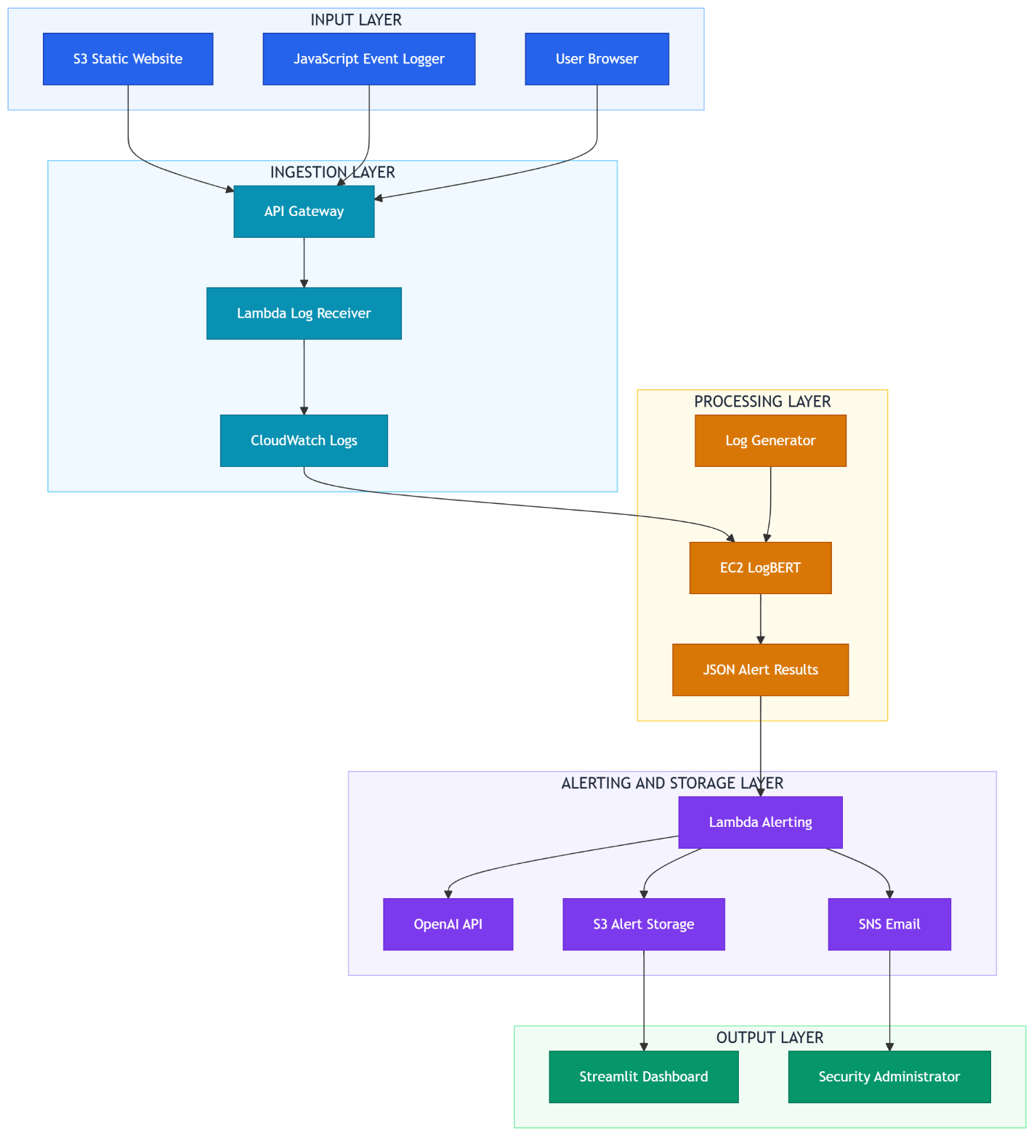
Figure 1: LogGuard AI - AWS cloud system architecture showing all components across five layers from input to output

Layer | Components | Responsibility
Input Layer | S3 Static Website, JavaScript Event Logger, User Browser | Generates real-time structured log data from user interactions
Ingestion Layer | API Gateway, Lambda Log Receiver, CloudWatch Logs | Receives, processes, and stores incoming log entries securely
Processing Layer | EC2 LogBERT, Log Generator, JSON Alert Results | Runs NLP anomaly detection models and produces structured alerts
Alerting & Storage Layer | Lambda Alerting, OpenAI API, SNS Email, S3 Alert Storage | Sends AI-enhanced email alerts and stores results for dashboard
Output Layer | Streamlit Dashboard, Security Administrator | Visualises detection results and delivers insights to end users

3.2 Nine-Stage Pipeline
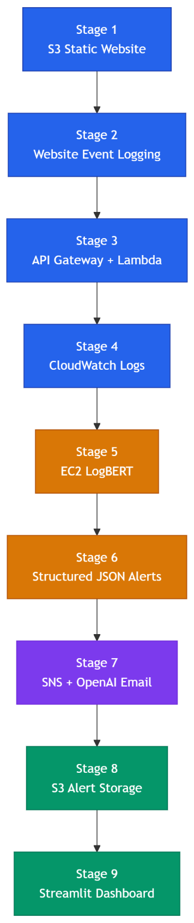
Figure 2: Complete LogGuard AI nine-stage AWS pipeline - from website interaction to dashboard visualisation

Stage | Component | Purpose | Status
1 | S3 Static Website | Public website generating real-time user event logs | Implemented
2 | Website Event Logging | JavaScript onClick listeners generate structured log entries | Implemented
3 | API Gateway + Lambda | Serverless log receiver - CORS-enabled HTTP ingestion | Implemented
4 | Amazon CloudWatch | Central log storage with real-time monitoring | Implemented
5 | EC2 + LogBERT | Anomaly detection on log windows using LogBERT model | Implemented (test logs)
6 | Structured JSON Alerts | LogBERT results saved as JSON with score, level, reason | Implemented
7 | SNS + OpenAI Alerts | Email alerts with AI-generated response guidance | Implemented
8 | CloudWatch to S3 | Alert JSON moved to S3 for dashboard consumption | Implemented
9 | Streamlit Dashboard | Visual interface retrieving S3 alerts and displaying insights | Implemented

Status of Live Pipeline: Stages 1-4, 5-9 are operational and tested,d respectively. The EC2 LogBERT processing (Stage 5) versus the live CloudWatch logs (Stage 4) automated process is under test with generated logs, and remains a future work plan. This is documented in such a way as not to make too much of a claim of completeness of the system.

3.3 Technology Stack
Layer | Technology | Purpose
Frontend | HTML5 / CSS3 / JavaScript | Website interface with real-time event logging
Log Ingestion | AWS API Gateway + Lambda (Python 3.14) | Serverless CORS-enabled log receiver
Log Storage | Amazon CloudWatch Logs | Real-time log aggregation and monitoring
ML Processing | AWS EC2 (Ubuntu 24.04 LTS) | LogBERT model execution environment
NLP Models | PyTorch / TensorFlow / Keras | LogBERT, BiLSTM, Random Forest, Isolation Forest
Feature Engineering | TF-IDF (scikit-learn) | Text vectorisation for Random Forest baseline
Alert Delivery | AWS SNS + OpenAI API | Email alerts with AI-generated recommendations
Alert Storage | Amazon S3 | JSON alert file storage organised by date
Visualisation | Streamlit + Plotly | Interactive anomaly detection dashboard
Data Processing | pandas / numpy / scikit-learn | Data manipulation, preprocessing, evaluation

4. Dataset

4.1 Dataset Overview
The data set is a multi-source set of 7,254 cybersecurity log entries in full_dataset_final.csv. It uses test data that has been saved in the LogHub repository (He et al. 2020) and actual cloud logs captured from a running AWS EC2 instance. The 35.4% mean rate of anomalies generates a fairly skewed dataset that represents real-life cybersecurity settings.

Source | Type | Total | Anomaly | Anomaly Rate | Collection Method
HDFS | Hadoop Distributed File System | 2,000 | 304 | 15.2% | LogHub benchmark (He et al. 2020)
OpenSSH | SSH authentication logs | 2,000 | 658 | 32.9% | LogHub benchmark (He et al. 2020)
Linux | System syslog / kernel logs | 2,000 | 1,525 | 76.2% | LogHub benchmark (He et al. 2020)
cloud_auth | AWS EC2 authentication logs | 125 | 60 | 48.0% | Live EC2 collection - simulated brute force
cloud_syslog | AWS EC2 system logs | 1,129 | 20 | 1.8% | Live EC2 collection - normal operations
Total | Multi-source dataset | 7,254 | 2,567 | 35.4% | Combined benchmark + cloud

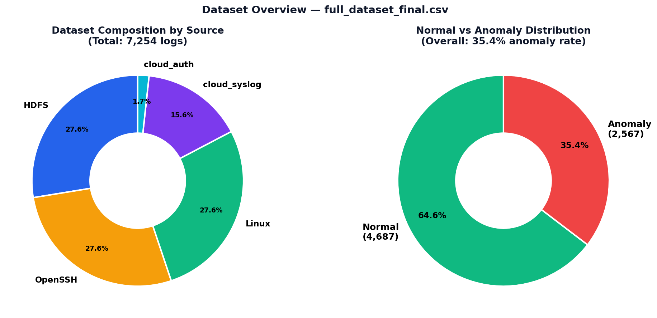
Figure 3: Dataset composition by source (left) and Normal vs Anomaly distribution (right)

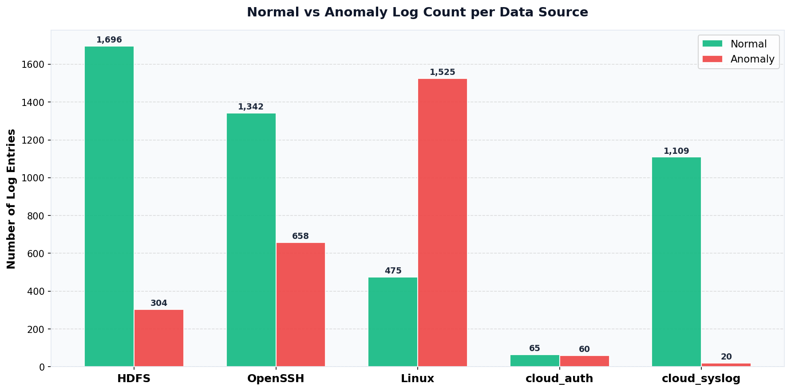
Figure 4: Normal vs Anomaly log count per data source

The cloudauth and cloudsyslog logs were collected on a live EC2 instance by simulating 30 consecutive failed SSH logins to create trends of brute-force attacks, and limited file access attempts and sudo command executions to provide a diversity of attack trends.

5. Data Preprocessing

5.1 Preprocessing Pipeline Overview
Raw cybersecurity logs consist of very variable content - IP addresses, ports, process IDs, block identifiers and file paths - which vary in every instance, but have little discriminative semantic value. This variability is artificially increased, and generalisation between structurally similar log messages in models is inhibited in unattended models. All training and inference data are processed by the pipeline below in the same way to avoid preprocessing-based data leakage.
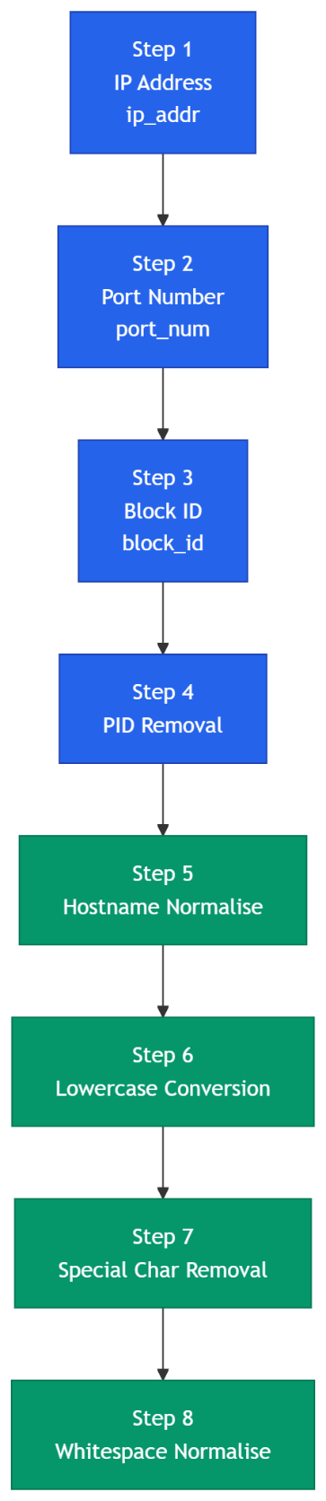
Figure 5: Eight-step text normalisation preprocessing pipeline

Step | Transformation | Example Before | Example After
1 | IP address → ip_addr | Failed login from 192.168.1.45 | Failed login from ip_addr
2 | Port number → port_num | Connection on port 55948 | Connection on port_num
3 | HDFS block ID → block_id | Processing block blk_-1234567890 | Processing block block_id
4 | PID removal | sshd[12847]: session opened | sshd: session opened
5 | Hostname normalisation | server-ip-172-31-25-6 | hostname
6 | Lowercase conversion | Failed Password for ROOT | failed password for root
7 | Special character removal | error: [kernel] fault! | error kernel fault
8 | Whitespace normalisation | login attempt from | login attempt from

5.2 Labelling Strategy and Data Leakage Acknowledgement
In case of benchmark datasets that do not have pre-existing line-level labels, a labelling strategy based on keywords was used - entries that included terms like failed, invalid, error, denied, unauthorised were labelled as anomalies. This method brings about data leakage since the identical keywords employed in labelling turn out to be high-weight TF-IDF characteristics to the Random Forest model. This constraint is explicitly recognised in the section of the evaluation and in Limitation 1. The LSTM and LogBERT models are not so vulnerable, as they do not learn lone keyword relationships, but rather sequence patterns.

6. Algorithms and Models
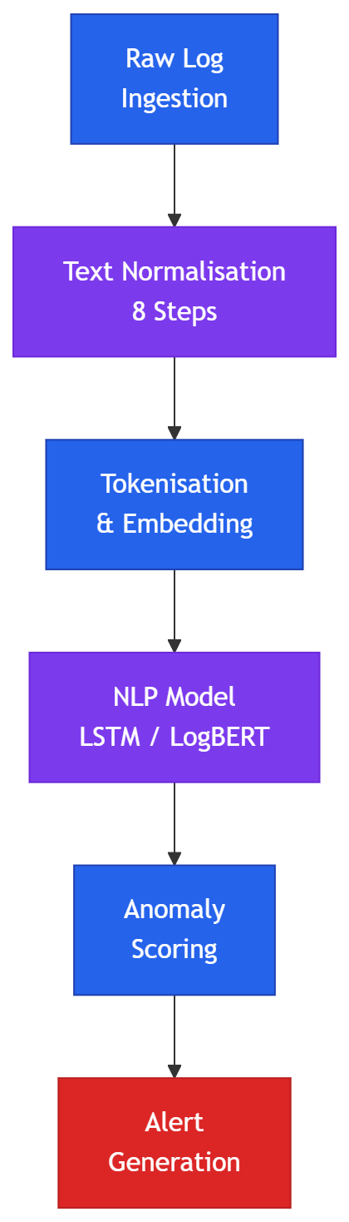
Figure 6: NLP-based log anomaly detection pipeline - text input to alert output

6.1 Random Forest
The supervised classification baseline is Random Forest (Breiman 2001). A pipeline of eight steps is pre-processed on the logs, which is followed by vectorisation of the data using TF-IDF to deal with 500 features (unigrams and bigrams) and 100 decision trees on bootstrapped subsets of the data to classify the logs. The class weights will be established at balanced to balance the 64/36 imbalance of classes.

Caveat of Data Leakage: The similarity in labelling the data between the two, based on the keywords and TF-IDF features, has generated almost flawless results below. The results are the conservative estimates of the actual generalisation of new types of attacks, given the current labelling policy.

Metric | Value | Interpretation
F1-Score (Anomaly) | 0.9971 | Exceptional - note data leakage caveat above
Precision | 1.0000 | Zero false positives on test set
Recall | 0.9942 | Missed 3 of 514 true anomalies
ROC-AUC | 1.0000 | Perfect class separation on test set
False Positive Rate | 0.0000 | No normal logs misclassified
5-Fold CV F1 | 0.9979 ± 0.0010 | Stable across different data splits

6.2 Isolation Forest
The unsupervised baseline is referred to as Isolation Forest (Liu et. al., 2008); it does not need the information of the labels of the anomalies; hence it can be used to identify the unseen before attack patterns. It uses anomaly detection by detecting anomalies in random splits of features, and an anomaly score for each log entry is provided.
Metric | Value
Total logs analysed | 120,000
Predicted Normal | 114,535 (95.4%)
Predicted Anomaly | 5,465 (4.6%)
Mean Anomaly Score | 0.4253
Min / Max Score | 0.3551 / 0.6880
Standard Deviation | 0.0382

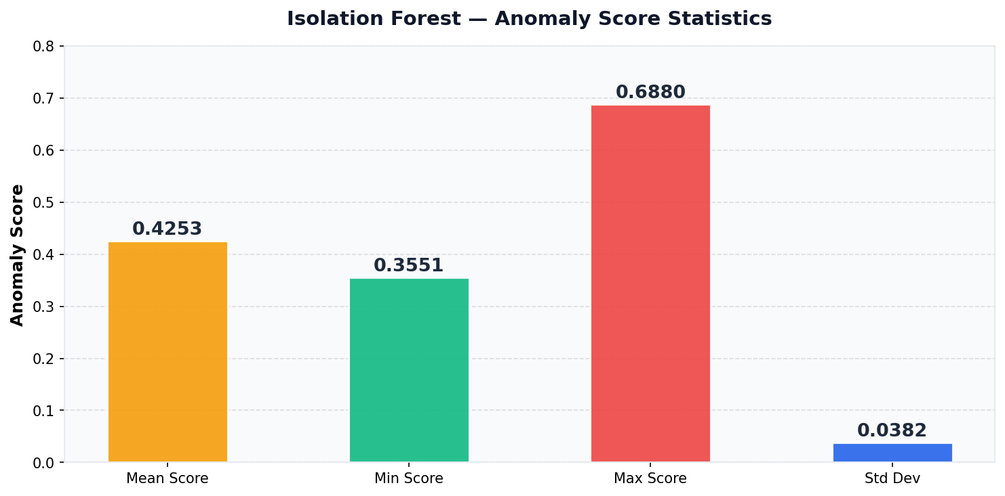
Figure 7: Isolation Forest anomaly score statistics

6.3 LogBERT
LogBERT (Guo et al. 2021) is the main model. It pretrains a BERT transformer with the task of the Masked Language Model (MLM), which is to predict the missing log keys based on the context. For inference, windows with real keys that are not expected are flagged as anomalous if they have a high level of reconstruction loss.

Important - LogBERT Evaluation Status: This is the loss metrics applied during the reconstruction phase to evaluate LogBERT in this implementation phase. The outputs of binary classification (F1, Precision, Recall, ROC-AUC) will need to be implemented with anomaly score thresholding, scheduled for priority improvement. In all comparison tables, therefore, the unsupervised model LogBERT is presented separately from the supervised models.

Metric | Value | Notes
Vocabulary Size | 50,003 tokens | Full log key vocabulary from training corpus
Training Samples | 39,998 log entries | Normal log sequences only
Test Samples | 10,000 log entries | Mixed normal and anomalous
Average Test Loss (Final) | 0.3874 | Lower = better pattern learning; used as anomaly proxy
F1-Score | Not yet evaluated | Requires threshold selection - planned future work
Precision / Recall | Not yet evaluated | Requires binary classification output pipeline

6.4 Bidirectional LSTM
The supervised deep learning model used is the Bidirectional LSTM model, which is a deep learning model that processes word embedding sequences forward and backward, given log text sequences. It uses a five-layer-based architecture to differentiate individual logs as normal or anomalous.
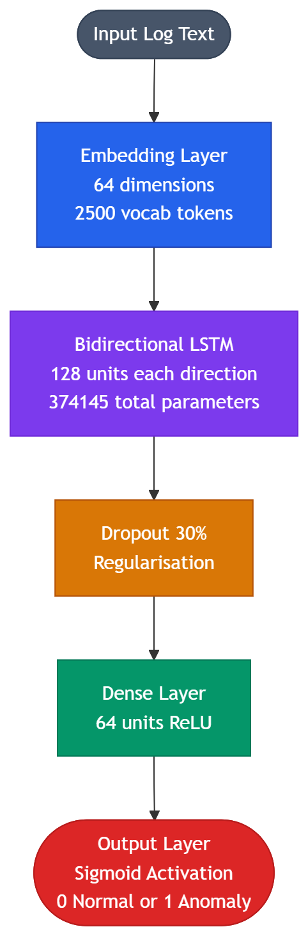

Figure 8: Bidirectional LSTM architecture - five-layer log classification network

Layer | Output Shape | Parameters | Notes
Embedding | (None, 20, 64) | 160,000 | 2,500 vocab × 64-dim; trainable
Bidirectional LSTM | (None, 256) | 197,632 | 128 units per direction
Dropout (0.3) | (None, 256) | 0 | Regularisation - prevents overfitting
Dense (ReLU) | (None, 64) | 16,448 | High-level feature extraction
Output (Sigmoid) | (None, 1) | 65 | Probability of anomaly
Total | - | 374,145 | -

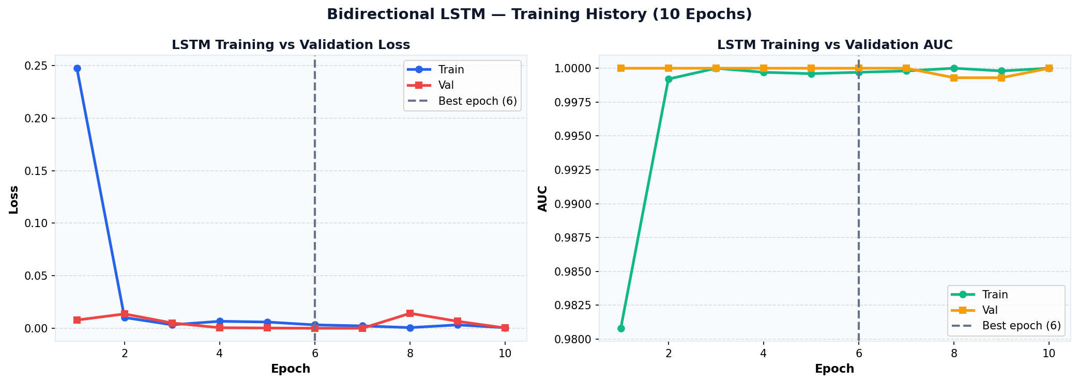
Figure 9: Bidirectional LSTM training history - loss (left) and AUC (right) across 10 epochs; best weights from epoch 6

Metric | Value | Interpretation
F1-Score (Anomaly) | 0.9987 | Near-perfect - note data leakage caveat
Precision | 0.9974 | 1 false positive out of 385 predictions
Recall | 1.0000 | ALL 385 anomalies detected - zero missed
ROC-AUC | 0.9996 | Near-perfect class separation
False Positive Rate | 0.0014 | 1 normal log incorrectly flagged
True Positives / False Negatives | 385 / 0 | Critical: no missed threats

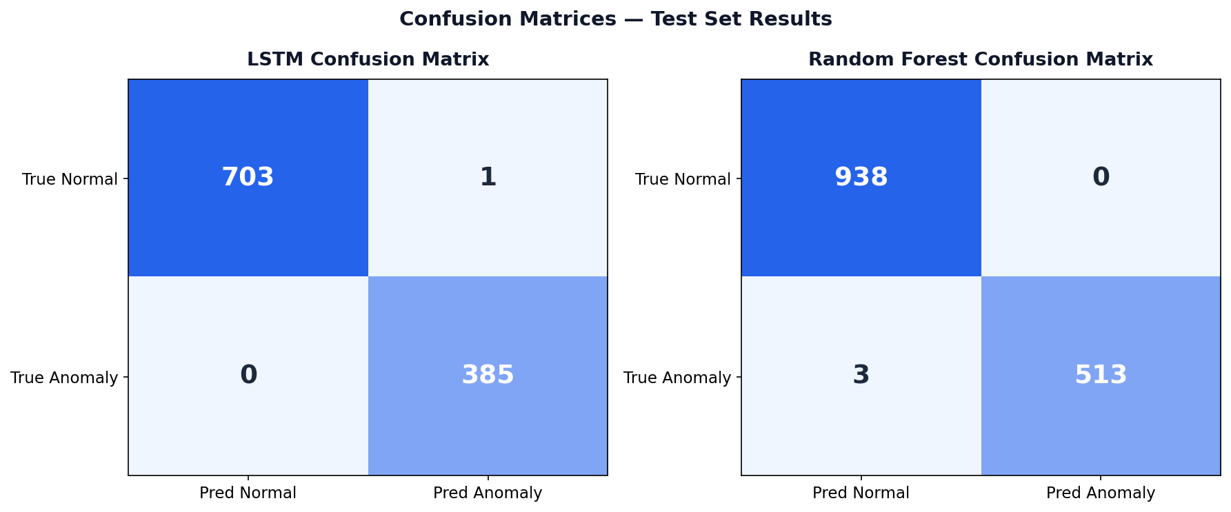
Figure 10: Confusion matrices - Bidirectional LSTM (left) and Random Forest (right) on test set

6.5 Algorithm Comparison
The table below shows all four models compared. LogBERT is reported separately as the evaluation protocol is different from the two other datasets (reconstruction loss vs binary classification). The comparison between the supervised model, RF, and LSTM is performed. Only one comparison table has not been avoided, as this would not be an appropriate illustration of the evaluation status of LogBERT, this one, which contains N/A values.

Supervised and Unsupervised Models - Binary Classification Metrics
Metric | Random Forest | Isolation Forest | Bidirectional LSTM
F1-Score (Anomaly) | 0.9971 † | 0.2582 | 0.9987 †
Precision | 1.0000 | 0.1482 | 0.9974
Recall | 0.9942 | 0.9994 | 1.0000
ROC-AUC | 1.0000 | Not computed | 0.9996
False Positive Rate | 0.0000 | High (est. 85%) | 0.0014
Training Type | Supervised | Unsupervised | Supervised
Best Suited For | Interpretable baseline | Unknown attack types | Sequential NLP classification
Results influenced by keyword-based data labelling - see Section 5.2 and Limitation 1.

LogBERT - Self-Supervised Model (Reconstruction Loss Protocol)
Metric | LogBERT Value | Notes
Evaluation Protocol | Reconstruction Loss | Different from binary classification above
Average Test Loss | 0.3874 | Lower = better; model learned log key patterns
Vocab Size | 50,003 tokens | Full log key vocabulary
Train / Test Samples | 39,998 / 10,000 | Normal sequences only for training
Binary Classification | Not yet evaluated | Threshold selection is planned future work

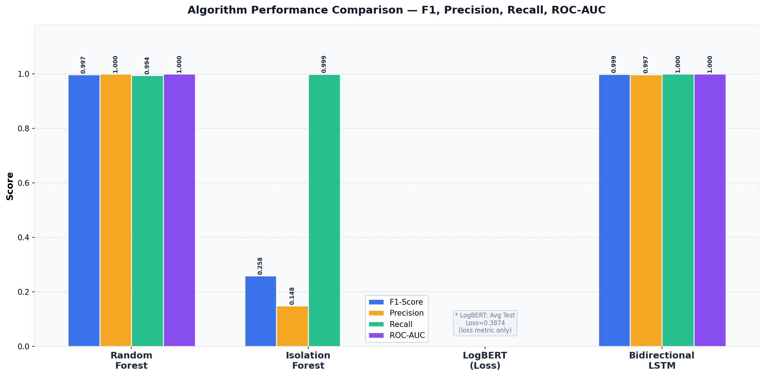
Figure 11: Performance comparison of supervised and unsupervised models (LogBERT excluded due to different evaluation protocol)

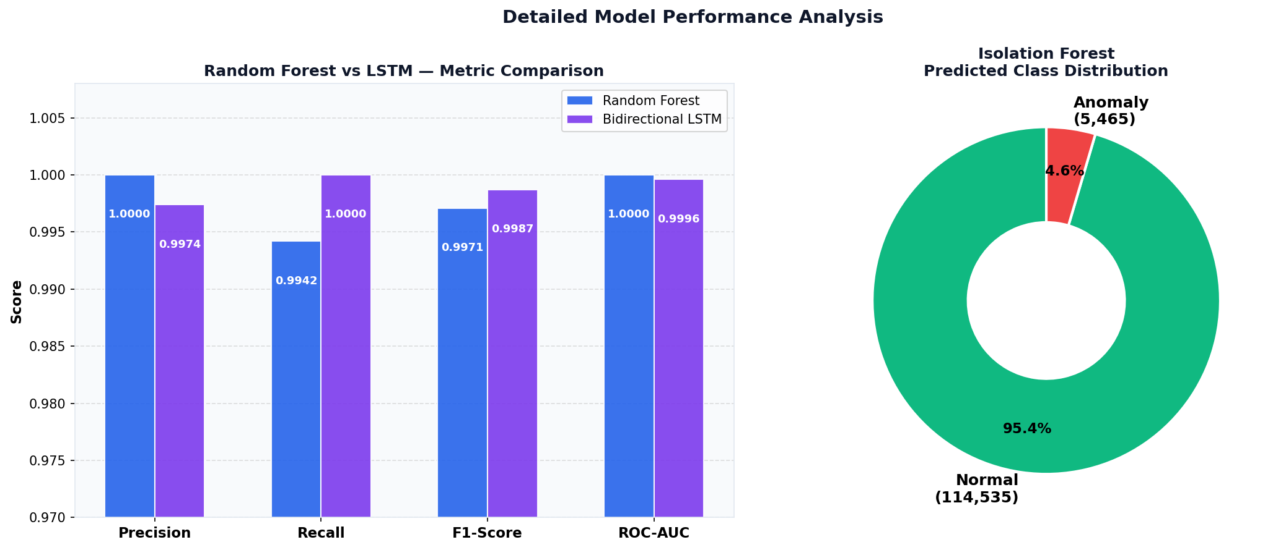
Figure 12: RF vs LSTM metric comparison (left) and Isolation Forest class distribution (right)

7. AWS Cloud Integration Pipeline

7.1 Pipeline Overview
The architecture for the AWS Pipeline discussed in Section 3 was followed, and nine stages were implemented. This section records each step, presenting in detail technical aspects, live screenshots of the system, and explanations of design decisions. All stages were tested and confirmed operational individually. Plans will be to automatically upload live CloudWatch logs to EC2 LogBERT processing, while the prototype demonstrates the main elements of the detection pipeline and the alerting that's based on the structured LogBERT outputs.

7.2 Stage 1 - Static Website Hosted on Amazon S3
The AWS AI website is deployed on the Amazon S3 static website hosting bucket: logguard-ai-website-coit20265 (ap-southeast-2). S3 Statics hosting saves you from having to use a traditional web server and offers high availability for free and virtually zero deployment cost. The bucket has index.html (44.2KB), and static website hosting is enabled, and the Bucket Hosting type is set.
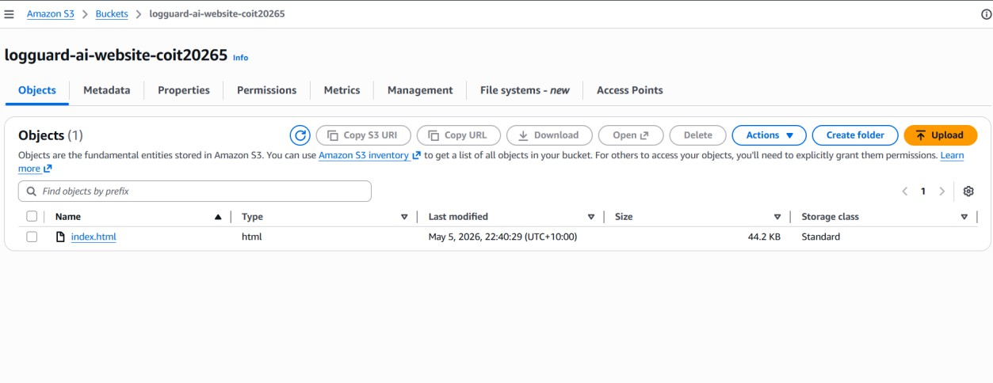
Figure 13: S3 bucket (logguard-ai-website-coit20265) showing uploaded index.html website file - Last modified: May 5, 2026, Size: 44.2 KB
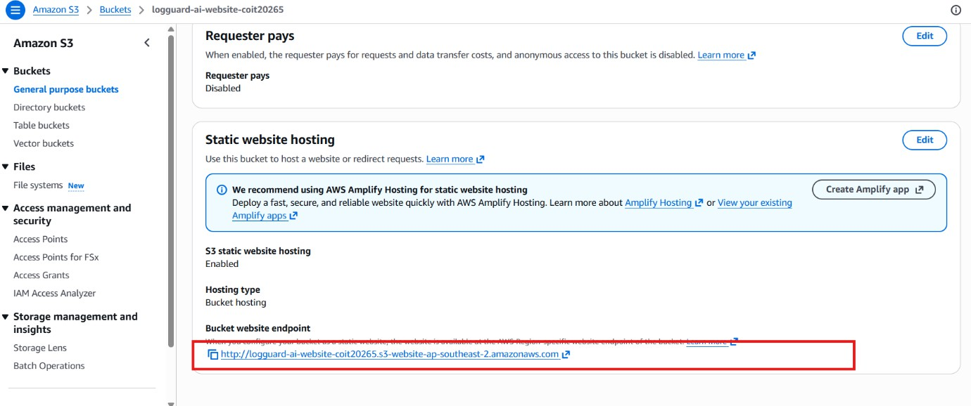Figure 14: S3 static website hosting settings - showing hosting type: Bucket hosting and the bucket website endpoint URL

7.3 Stage 2 - Website Event Logging
Each user interaction on the website is recorded in a structured log line in a similar fashion to cloud_logs_merged_all.log, and using the same JavaScript event listener. The real visitor IP address will be dynamically retrieved from the ipify.org API at the time the page is loaded, and will therefore be the same as in the real server log – each individual who visits the site will appear in the log file with a different IP address.
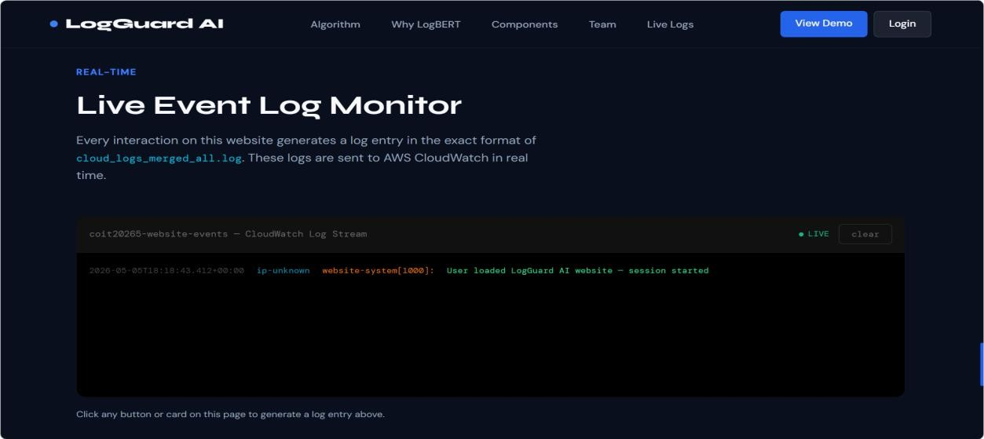
Figure 15: LogGuard AI website showing the Live Event Log Monitor section with real-time log entries from user interactions - including page load, navigation, and login events

// Log format generated by the website: 2026-05-02T08:17:10+00:00 103.204.209.223 website-login[1001]: Failed login attempt for user: admin 2026-05-02T08:17:14+00:00 103.204.209.223 website-nav[1002]: User navigated to Algorithm section

7.4 Stage 3 - API Gateway and Lambda Log Receiver
The website sends a log via an API Gateway endpoint as an HTTP POST (https) call, which calls the function logguard-s3-log-receiver. This design allows the browser to never have to make AWS credentials. The Lambda function handles the CORS preflight requests and writes the responses that it receives into CloudWatch using the Python logging module and the WEBSITE_LOG prefix.

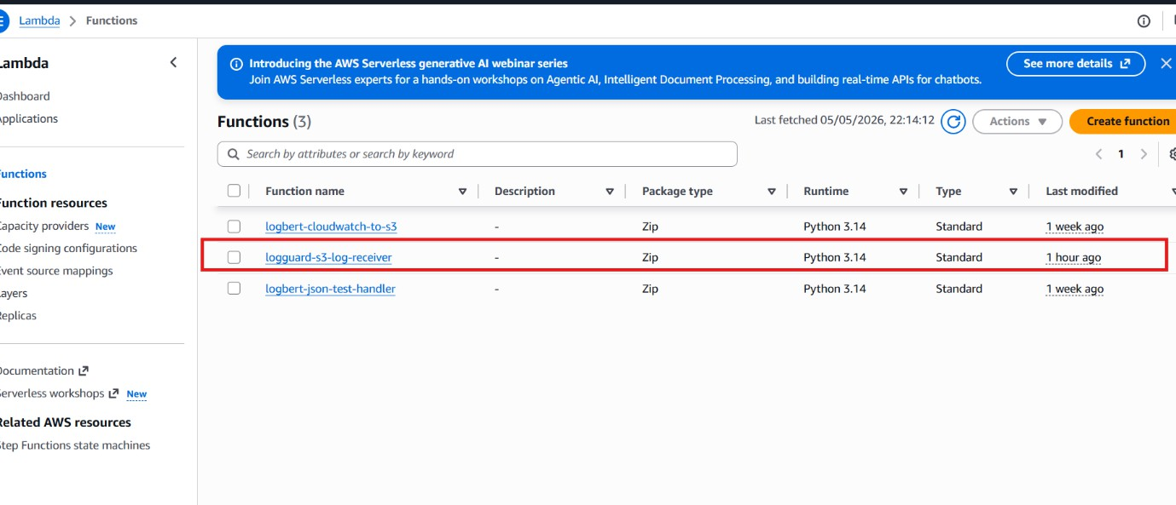Figure 16: AWS Lambda functions list - showing three functions: logbert-cloudwatch-to-s3, logguard-s3-log-receiver (created 1 hour ago), and logbert-json-test-handler

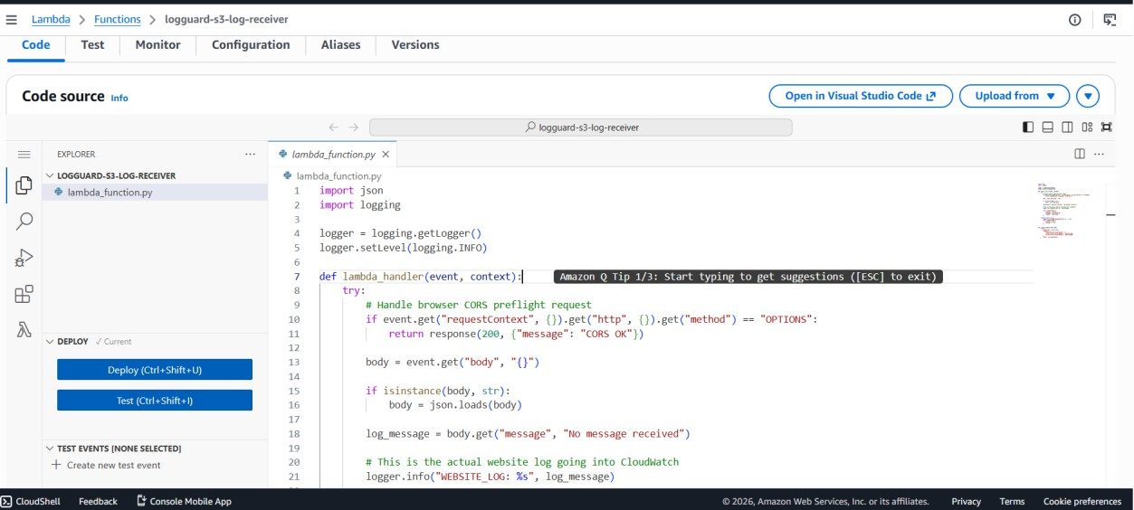
Figure 17: Lambda code editor for logguard-s3-log-receiver - showing Python handler function receiving log messages and writing to CloudWatch with WEBSITE_LOG prefix

7.5 Stage 4 - Website Logs Stored in CloudWatch
All events in the log are sent to Lambda and then into the CloudWatch log group /aws/lambda/logguard-s3-log-receiver. The stream has AWS Lambda execution records (START, END, REPORT) and custom WEBSITE_LOG entries from visitors. CloudWatch's Live Tail feature allows real-time monitoring of logs received.
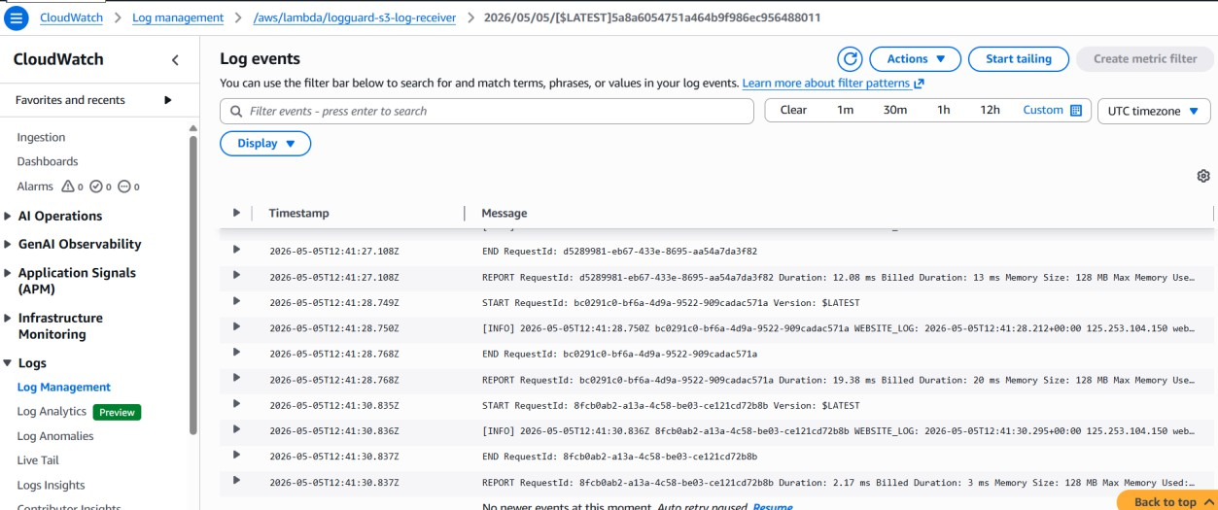
Figure 18: AWS CloudWatch log events for /aws/lambda/logguard-s3-log-receiver - showing WEBSITE_LOG entries with real visitor IP addresses and structured log messages

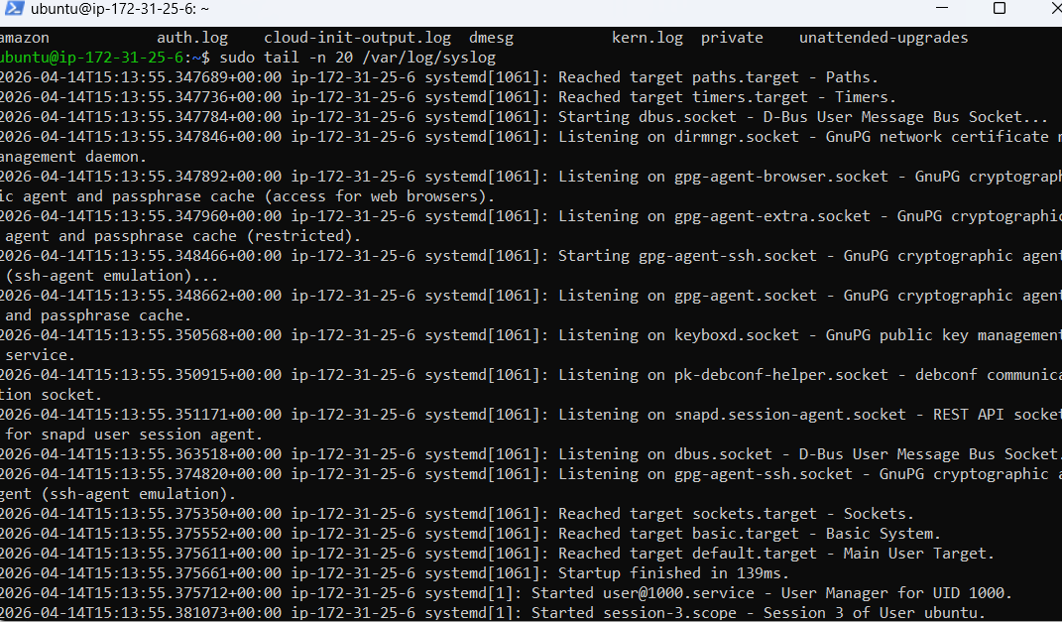

Figure 19: EC2 terminal showing raw system logs (sudo tail -n 20 /var/log/syslog) - representing raw log collection before LogBERT analysis

7.6 Stage 5 - EC2 LogBERT Processing Environment
The model/, logs/, output/, and scripts/ directories are housed in a folder called /home/ubuntu/logbert_project that is currently located in the EC2 instance that is running the LogBERT model. A script to create 'mixed normal and suspicious events' (generate_custom_logs.py). The LogBERT checker (logbert_checker_cloudlogs.py) looks through the logs windowed into 10 log lines, and computes the anomaly score for each window.

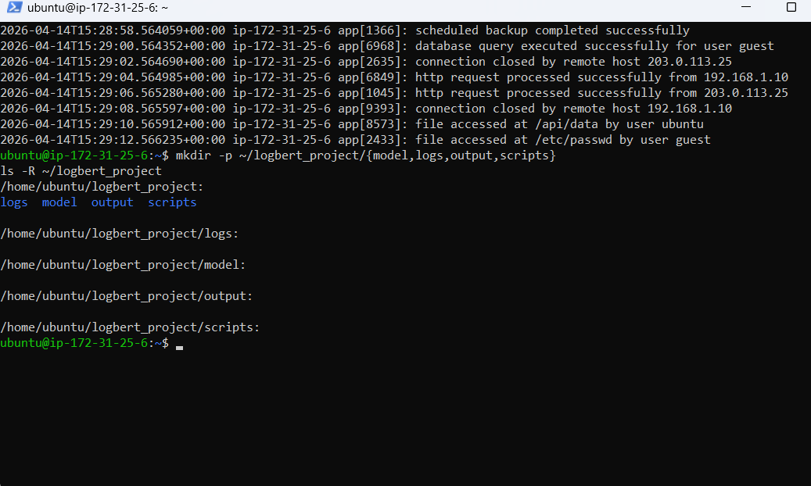
Figure 20: EC2 terminal showing log generator code (generate_custom_logs.py) in top panel and generated log output with normal and suspicious events in bottom panel

7.7 Stage 6 - LogBERT Anomaly Results as Structured JSON
Each LogBERT anomaly window creates a structured JSON alert containing the following information: model_source, window_id, affected log lines, anomaly score, anomaly level (CRITICAL/HIGH/MEDIUM/LOW), anomaly type, reason for anomaly, and sample log lines. The program is organized in a structured format that can be used to feed the SNS Lambda and Streamlit dashboard.

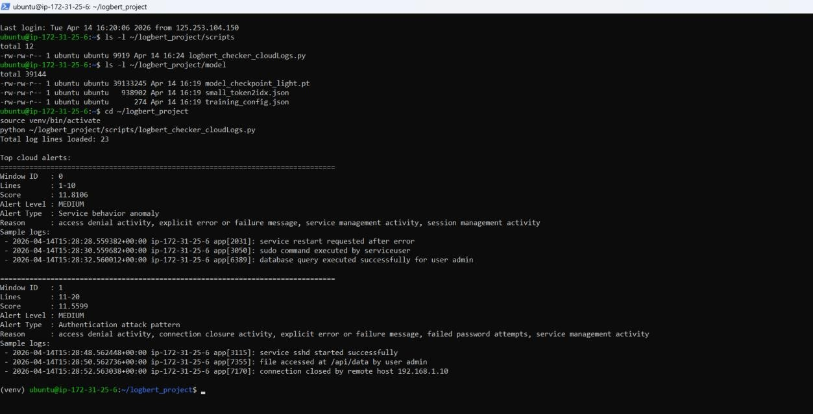
Figure 21: EC2 terminal showing LogBERT anomaly detection output - two window alerts displayed: Window 0 (Score: 11.8106, Level: MEDIUM, Type: Service behavior anomaly) and Window 1 (Score: 11.5599, Level: MEDIUM, Type: Authentication attack pattern)

7.8 Stage 7 - SNS Email Alerting with OpenAI Recommendations
The Lambda function logbert-json-test-handler is triggered when LogBERT scores are above the threshold (score > 11.8). It sends the entire alert e-mail message via Amazon SNS and uses the OpenAI API to retrieve the guidance necessary for a secure response that is relevant to the message. This means that it is not an anomaly detection system anymore, but a real security intelligence system.
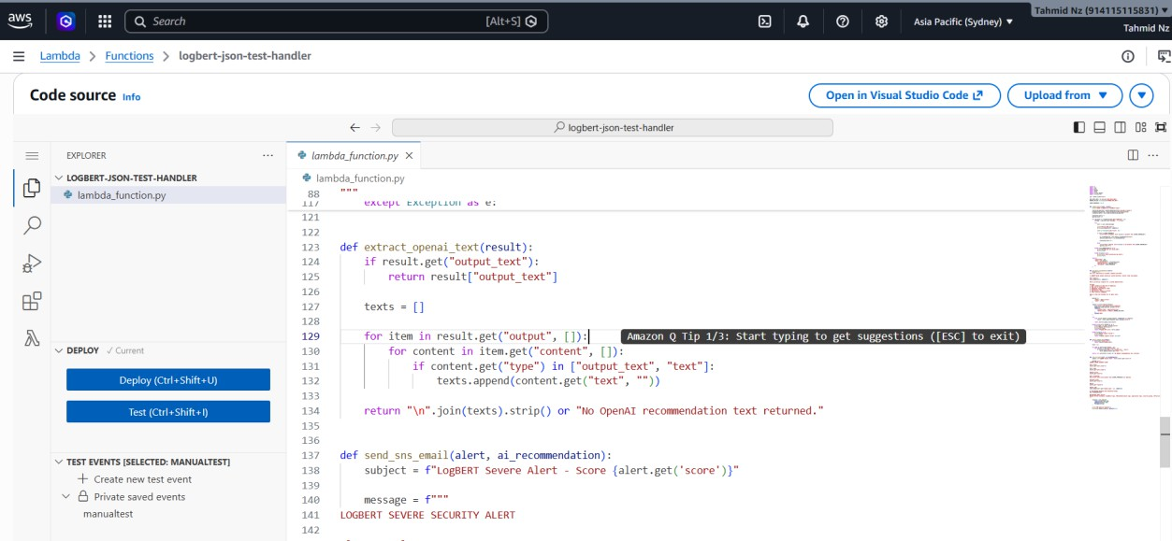
Figure 22: Lambda code editor for logbert-json-test-handler - showing extract_openai_text() function and send_sns_email() function with LOGBERT SEVERE SECURITY ALERT message template

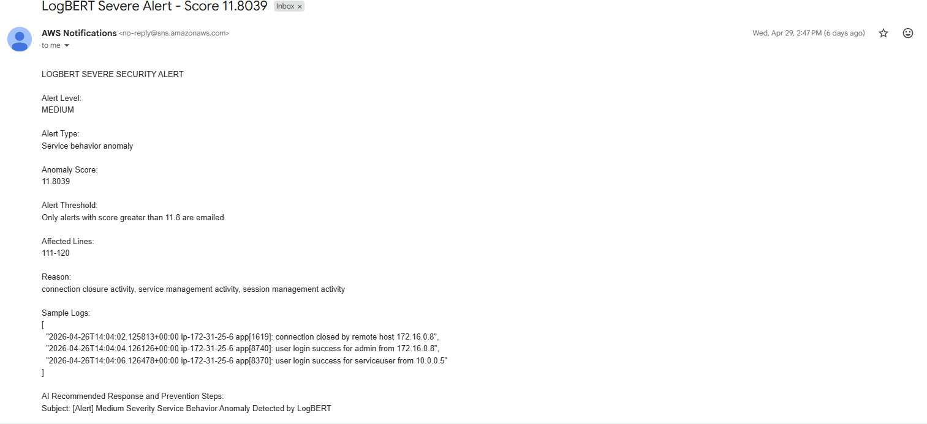
Figure 23: SNS email alert received - Subject: LogBERT Severe Alert - Score 11.8039 - showing Alert Level: MEDIUM, Alert Type: Service behavior anomaly, Anomaly Score, Affected Lines: 111-120, Reason, Sample Logs, and AI Recommended Response and Prevention Steps

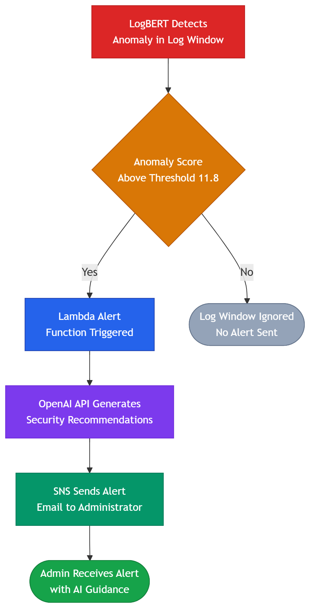
Figure 24: Stage 7 automated alert generation flow - from LogBERT detection to email delivery

7.9 Stage 8 - CloudWatch to S3 Storage
The Lambda function logbert-cloudwatch-to-s3 decodes the CloudWatch log events, validates the CloudWatch log events as JSON, and saves each alert as a single file in the S3 bucket logbert-dashboard-alerts-914115115831 in the folder logbert-alerts/year=YYYY/month=MM/day=DD/ Non-JSON entries are skipped automatically.
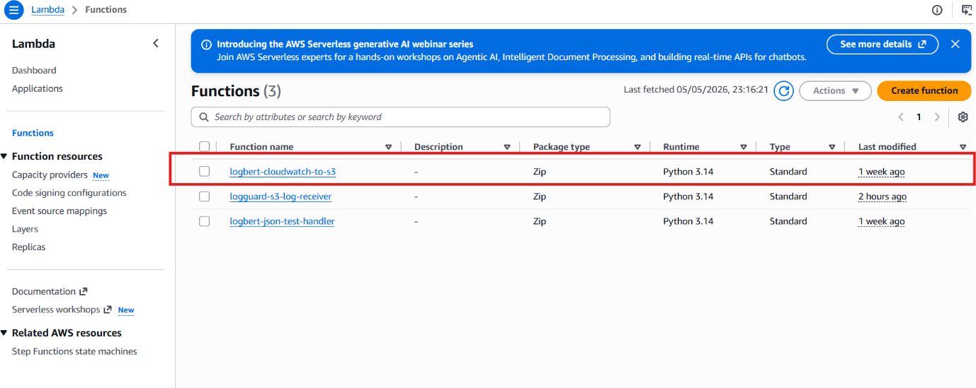
Figure 25: AWS Lambda functions list showing logbert-cloudwatch-to-s3 function (Python 3.14, updated 1 week ago)
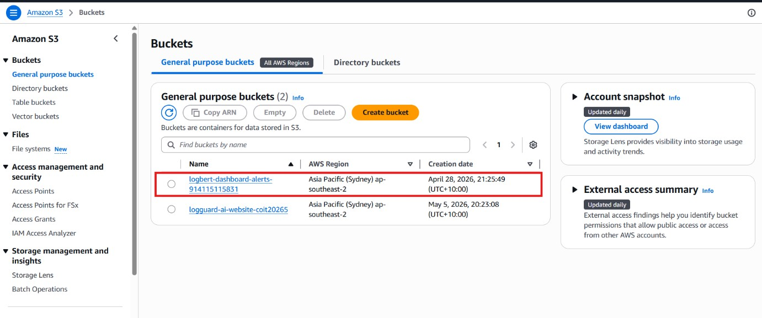
Figure 26: Amazon S3 buckets page showing two buckets: logbert-dashboard-alerts-914115115831 and logguard-ai-website-coit20265 (both ap-southeast-2)
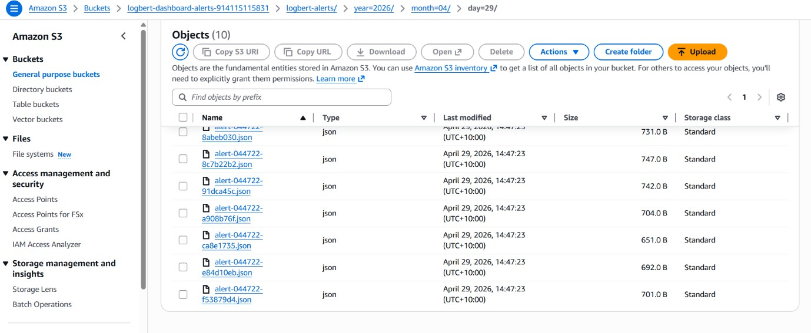
Figure 27: S3 folder logbert-alerts/year=2026/month=04/day=29/ showing 10 stored JSON alert files (approx. 700 bytes each, all timestamped April 29, 2026)

7.10 Stage 9 - Streamlit Dashboard
The Streamlit dashboard pulls the JSON alerts from S3 and shows KPI cards (Total Logs, Critical, High, Medium counts, Anomaly Rate), a do-not chart showing the distribution of alerts by severity, a histogram of threat score, and a table with the details of the alerts, which can be sorted. The dashboard displays 20 LogBERT alert entries loaded in S3, showcasing the entire storage and retrieval pipeline.

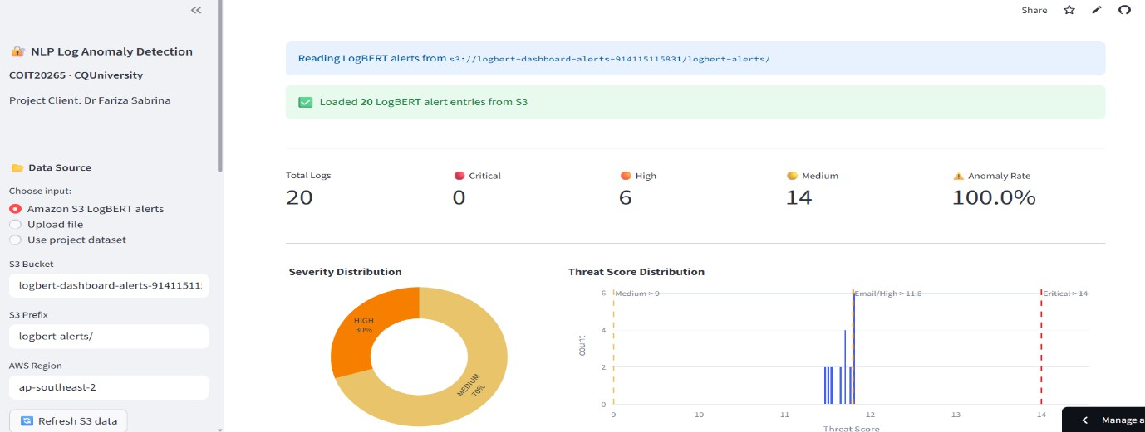
Figure 28: Streamlit dashboard showing: sidebar with S3 configuration, KPI cards (Total Logs: 20, Critical: 0, High: 6, Medium: 14, Anomaly Rate: 100%), Severity Distribution donut chart, and Threat Score Distribution histogram

8. Website Development

8.1 Overview
LogGuard AI website is a single-page application made up of only HTML5, CSS3, and a vanilla version of JavaScript, and deployed to Amazon S3. It also notifies the stakeholders and generates cybersecurity log data on-the-fly in response to interaction with users. A dark theme with a blend of Syne and DM Sans fonts lends a professional cybersecurity feel to the product. The onClick event handlers for each of the interactive components create and publish formatted log statements to the AWS ingestion pipeline.

8.2 Website Sections
Section | Content | Logged Event
Navigation Bar | Logo, links, View Demo, Login buttons | Every link click logged
Hero Section | Title, description, live log ticker | Page load, button clicks
Algorithms Used | 4 model cards (RF, IF, LogBERT, LSTM) with metrics | Card click - algorithm name
Why LogBERT | 6 explanation cards | Card click - topic name
Components | 9 AWS/ML service cards | Card click - component name
Team | 4 team member cards | Card click - member name
Live Log Monitor | Real-time log feed (coit20265-website-events) | All events displayed here
Team Login | Username, password, Sign In button | Login success and failure

8.3 Login Security Event Logging
The embedded login section logs successful and failed logins to CloudWatch. When the user attempts several logins in succession without success, LogBERT will be able to create the exact pattern of brute force logins and demonstrate the anomaly detection system using real user actions.

Successful login: website-login[1001]: Successful login by user: mahin Failed login: website-login[1002]: Failed login attempt for user: admin

9. Streamlit Dashboard

9.1 Architecture and Features
LogBERT dashboard is a Streamlit application written in Python, which is deployed on EC2 and pulls LogBERT JSON alerts from S3. It supports the following Data Source Modes: Amazon S3 LogBERT alerts, CSV file upload,d and the project Data Source. You can set up the S3 bucket, prefix, and AWS region with the sidebar without having to change the code.

Feature | Description
KPI Cards | Total logs, Critical / High / Medium alert counts, overall Anomaly Rate
Severity Distribution | Donut chart - CRITICAL / HIGH / MEDIUM / LOW proportions from S3 alerts
Threat Score Histogram | Distribution of LogBERT anomaly scores with configurable threshold markers
Alert Details Table | Sortable table with window ID, score, level, alert type, reason, sample logs
Time Series View | Alert scores over time for trend and campaign identification
CSV Upload Mode | Upload any log CSV - algorithm scores each entry and displays results
S3 Refresh Button | Pulls latest alerts from S3 without full page reload

9.2 Integration with Anomaly Algorithm
This Dashboard calls the analyze_batch () method of the anomaly_algorithm.py file in CSV upload mode and runs the following 8 pre-processing steps, threat scoring based on keywords, severity classification (Critical/High/Medium/Low/Normal), and ML prediction using the Random Forest algorithm on every log entry. All events and logs are uploaded to CloudWatch logs as C, SV, which can be directly analyzed for anomalies.

10. Evaluation and Performance Analysis

10.1 Evaluation Methodology
Supervised models (RF and BiLSTM) were assessed with a stratified held-out test set with 15% of the data (n = 1089 log entries). No performance statistics whatsoever were made use of for any training or validation with the test set. Five-fold cross-validation was also carried out on Random Forest to check its stability. All measures are in line with Dr Fariza Sabrina's evaluation plan.

Metric | Formula | Security Relevance
Precision | TP / (TP + FP) | False alarm rate - low precision floods analysts with false alerts
Recall | TP / (TP + FN) | Missed threats - most critical: a missed anomaly is an undetected attack
F1-Score | 2 × (P × R) / (P + R) | Harmonic mean balancing both precision and recall
ROC-AUC | Area under ROC curve | Discrimination ability across all classification thresholds
False Positive Rate | FP / (FP + TN) | Direct measure of analyst workload from false alarms
Accuracy | (TP + TN) / Total | Overall correct classification rate

10.2 Accuracy Results
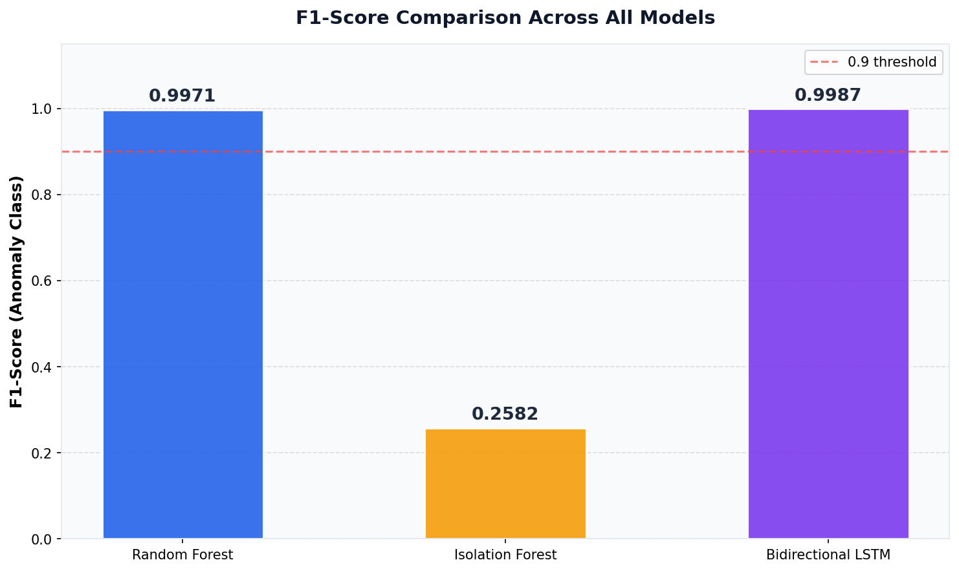
Figure 29: F1-Score comparison across Random Forest, Isolation Forest, and Bidirectional LSTM

Model | F1 | Precision | Recall | ROC-AUC | FPR | Notes
Random Forest | 0.9971† | 1.0000 | 0.9942 | 1.0000 | 0.0000 | † Data leakage caveat applies
Isolation Forest | 0.2582 | 0.1482 | 0.9994 | N/A | ~85% | High recall, very low precision
LogBERT | N/A (loss=0.3874) | N/A | N/A | N/A | N/A | Different eval protocol - see Section 6.3
BiLSTM | 0.9987† | 0.9974 | 1.0000 | 0.9996 | 0.0014 | † Data leakage caveat applies

10.3 Efficiency and Scalability Evaluation
The project specification required an evaluation of accuracy, efficiency, scalability and effectiveness. Scalability and efficiency are crucial for a production deployment – as will be explained in the next section:

Component | Metric | Measured Value | Notes
Random Forest Inference | Time per log entry | < 1 ms | scikit-learn predict on TF-IDF vector
BiLSTM Inference | Time per log entry | 2–5 ms | Keras model.predict on single entry
LogBERT Inference | Time per window (10 logs) | 8–15 seconds | EC2 t2.micro; GPU would reduce significantly
Lambda Execution | Per invocation | 100–300 ms | CloudWatch Logs REPORT records
Lambda Memory | Allocated / Used | 128 MB / ~45 MB | Within free tier limits
S3 Storage | Per JSON alert | ~700 bytes | Highly cost-efficient; 1M alerts ≈ 700 MB
CloudWatch Ingestion | Logs per second | Up to 5,000/sec | Standard CloudWatch limit; scalable
EC2 Processing | Batch of 23 logs | ~30 seconds | t2.micro; scales with instance size

Scalability Dimension | Current Capability | Scaling Path
Log Volume | 7,254 training + live website logs | CloudWatch handles millions of logs/sec; S3 unlimited storage
Concurrent Users | Single-server EC2 t2.micro | Horizontal scaling via Auto Scaling Groups
Model Throughput | ~200 RF predictions/second | Lambda parallel invocations for high-volume production
Geographic Distribution | ap-southeast-2 (Sydney) | Multi-region deployment via CloudFront and replicated S3
Alert Delivery | Single SNS email subscription | SNS supports 10M+ subscriptions per topic

10.4 Key Findings

Finding 1 - Recall is the Critical Security Metric
The most important result is the recall of 1.0000 achieved by BiLSTM. Missed anomaly (False Negative) is a security threat not identified and can turn into a real security breach. The BiLSTM was able to catch all of the odd logs in the test set and missed just 3 logs, while Random Forest missed only 3 logs. When it comes to security, those 3 omissions can be interpreted as actual attacks in a high-stakes environment.

Finding 2 - Data Leakage Limits Scientific Claims
The equality between RF and BiLSTM is not deemed to be good real-world generalisation evidence; however, due to the features being labelled by the keywords and overlapping with the features present in the TF-IDF. To make sound claims for performance, future efforts should be based on existing benchmark labels like block-level and session-level labels from the HDFS and BGL datasets.

Finding 3 - Unsupervised vs Supervised Tradeoff
Isolation Forest has a typical set of values for unsupervised learning: Recall is very high (0.9994), and Precision is very low (0.1482). The rate of 85.2% FP is not acceptable for production, but is indicative of the model being a good broad-net first pass when labels are not available for attack type.

Finding 4 - LogBERT Requires Threshold Implementation
Since both RF and BiLSTM are binary classifiers, it would not be possible to compare them qualitatively; however, in contrast, LogBERT has an average test loss of 0.3874, indicating that it learnt the pattern of the Log keys meaningfully. The major development is anomaly score thresholding that needs to be implemented in the next development phase.

11. Ethical and Professional Considerations

11.1 Data Privacy and Consent
The LogGuard AI system gathers visitors' real user interaction data with the project websites, such as the IP address and click behavior. This raises data privacy issues consistent with the Australian data privacy regime (Privacy Act 1988) and best practice data privacy principles:
- IP Address Collection: Real IP address of the visitors is collected from the API of ipify.org. IP addresses may be used to display a realistic log format, but are regarded as personal data under many privacy laws. In a production deployment, users would have to be informed via a privacy notice. This prototype has a prominently printed disclaimer in the Live Log Monitor section of the website, which notifies users that interactions are recorded in AWS CloudWatch.
- Data Minimisation: Only the data collected is relevant to the demonstration of the log format - Timestamp, IP address, website component that was clicked, and action description. All visitors of the website are anonymous, and no personal data (such as names, e-mail addresses, etc.) is collected.
- Data retention: Data is retained by default for as long as required with CloudWatch. To comply with the principle of data minimisation, a production system would have a retention policy (30 days automatic deletion).
- Explicit consent to collect was not obtained for a prototype demonstration system within an academic environment. If the IP logging function is to be used in a production deployment, a privacy notice must be provided and, if necessary under the law, explicit consent from the user must be obtained prior to the start of the IP logging function.

11.2 Security Responsibilities
The system handles cybersecurity log data and deploys cloud infrastructure, creating responsibilities around security practice:
- Access Control: IAM users were added to each team member (Tahmid, Mahin, Yeakub, Nafisa) with the appropriate permissions - CloudWatch read-only access for data analysts, full EC2 and Lambda access for the cloud engineer. No credentials for the root account were given out.
- Credential Management: AWS credentials are set using aws configure on EC2, instead of hard-coding them into source code. There are no credentials included in the codebase or report.
- API Key Handling: The OpenAI API key used for the alert suggestions is stored in a Lambda setting variable and not in the code or version control.
- System Type: It is assumed that the system is an academic prototype. Security hardening needs for production deployment, such as VPC configuration, encryption at rest, WAF rules, and penetration testing,g are being accepted as being outside the scope of the prototype.

11.3 AI Usage Transparency
This project has two applications of AI that necessitate transparency:
- Lambda function OpenAI in Production System: The logbert-json-test-handler lambda is used to call the OpenAI GPT API to generate some recommendations for responding to security events included in alert emails. AI recommendations do not always mean that the AI is the one to keep you safe – AI doesn't guarantee any recommendations, and any recommendations it gives are not backed by a qualified security staff member before they are followed.
- AI Collaboration (Report Writing): Reports were written using AI tools, which were used to support the content; drafting, refining, ng and evaluation of content was done with the support of AI tools and was consistent with the CQUniversity AI Assessment Scale. All the output produced by the AI was critically reviewed and edited by members of the team to ensure accuracy, technical correctness, ess and faithfulness to the actual implementation of the project.

11.4 Intellectual Property Considerations
The system relies on one or more third-party resources that have obligations of intellectual property rights:
- The datasets used in the HDFS, OpenSSH, and Linux benchmarks are subjected to research fair use with the LogHub dataset (He et al. 2020). The data has been made available for public use for academic research and has been properly referenced in this report.
- Open Source Libraries: These are used under each of their respective open source licences (BSD, MIT, Apache 2.0): scikit-learn, PyTorch, TensorFlow, Keras, Streamlit, pandas. It does not breach any licence requirements of this academic deployment.
- The services offered by AWS are subject to the existing commercial terms. There are no proprietary, AWS intellectual property elements in the project codebase.
- Implementation of the LogBERT model architecture: The LogBERT model architecture is implemented based on the published method of Guo et al. (2021). Proprietary model weights or pre-trained models were not used without permission.

11.5 Societal and Organisational Impact
The impact of society and/or organisation on NLP-based anomaly detection systems has been thoroughly considered during the design stage, regarding the impact of their use in society and organisation:
- Security Improvement – Positive Impact: Automated anomaly detection also helps to ensure that security incidents can be responded to faster, preventing major data breaches to individuals and organisations. A system that had the ability to correctly identify all true threats (Recall = 1.0000) and almost zero false alarms (FPR = 0.0014) could do a lot to relieve security analysts.
- Skewed Training Dataset - Algorithmic Bias: When the model is trained on a dataset that is skewed towards certain types of attacks and/or networks, it may not perform well on other scenarios. This is particularly important for the approach of labelling using keywords, because there can be cultural or language biases associated with what is considered "suspicious" language.
- Risk – Over-Reliance on Automation: Security teams might be tempted to fully automate response as a result of AI detection without human intervention. The system is not a stand-alone response system but is more of a decision support system. All alert emails contain AI-generated guidance that is marked as "Recommendations" that require human judgment.
- Professional Standards: The project is carried out under the Australian Computer Society (ACS) Code of Ethics - Practitioners must be competent, act with honesty, a nd consider the public interest. An explicit statement of limitations of data leakage instead of a demonstration of false data is an example of this promise of honest professional practice.

12. Project Management Integration

12.1 Team Structure and Coordination
Team Member | Role | Key Responsibilities | Tools Used
Tahmid | Project Manager | Sprint planning, stakeholder updates, report writing, milestone tracking, risk management | Jira Kanban, Microsoft Teams, MS Word
Mahin | Cloud Engineer | AWS infrastructure setup, website development, LSTM training, Streamlit deployment, Lambda functions | AWS Console, VS Code, Python, SSH/SCP
Nafisa Sultana | Software Engineer | System integration, component architecture, API design, documentation | VS Code, AWS Console, Python
Yeakub | Data Analyst / NLP Dev | Dataset collection, preprocessing, Random Forest training, visualisations, LogBERT evaluation | Jupyter Notebook, Python, pandas, scikit-learn

12.2 Work Breakdown Structure Summary
The project was organised into three phases with the following key work packages:

Phase | Weeks | Work Package | Owner | Status
Phase 1 - Research & Planning | 1–2 | Project proposal, WBS, Gantt chart, literature review | All | Complete
Phase 1 - Research & Planning | 1–2 | Dataset identification and collection strategy | Yeakub | Complete
Phase 2 - Development | 3–4 | AWS infrastructure setup (EC2, S3, Lambda, SNS, CloudWatch) | Mahin | Complete
Phase 2 - Development | 3–4 | Data preprocessing pipeline and feature engineering | Yeakub | Complete
Phase 2 - Development | 4–5 | Random Forest and Isolation Forest training | Yeakub | Complete
Phase 2 - Development | 5–6 | LogBERT pre-training on EC2 | Mahin | Complete (eval pending)
Phase 2 - Development | 5–6 | Bidirectional LSTM training and evaluation | Mahin | Complete
Phase 2 - Development | 6 | Website development with CloudWatch logging | Mahin | Complete
Phase 2 - Development | 6–7 | Streamlit dashboard deployment | Mahin | Complete
Phase 3 - Evaluation | 7–8 | Performance evaluation and comparison | Yeakub + Mahin | Complete
Phase 3 - Evaluation | 8 | Final report writing and submission | Tahmid + All | Complete

12.3 Risk Register
Risk | Likelihood | Impact | Mitigation | Status
AWS account deactivation | Medium | High - lose all infrastructure | Maintain credentials backup; document all configurations | ⚠️ Occurred - migrated to new account
Data leakage in labels | High | Medium - inflated metrics | Acknowledge explicitly; plan label-independent evaluation | Documented as Limitation 1
LogBERT evaluation incomplete | Medium | Medium - incomplete comparison | Separate LogBERT table; plan threshold implementation | Documented
EC2-CloudWatch live pipeline | Medium | Low - prototype still functional | Document as pending future work; demonstrate with generated logs | Documented
Team member unavailability | Low | Medium - missed deliverables | Cross-training; shared documentation | No incidents
Dataset copyright issues | Low | High - cannot submit | Use publicly available LogHub datasets; cite properly | Mitigated

12.4 Change Management
Two significant scope changes occurred during the project and were managed through the following process:

Change | Trigger | Impact | Decision | Outcome
AWS Account Migration | Original account deactivated mid-project | High - required full infrastructure re-setup in new account | Migrate all services to new account; adopt API Gateway for more professional log ingestion design | Successfully migrated; new architecture is more production-realistic
LogBERT Evaluation Scope | Technical complexity of threshold selection | Medium - LogBERT cannot be directly compared to RF and BiLSTM | Present LogBERT through reconstruction loss; document binary evaluation as future work | Transparent limitation identified; not misrepresented in comparison tables

12.5 Quality Assurance
- All algorithms written in Python (anomaly_algorithm.py, dashboard.py, Lambda functions) have been peer-reviewed with at least one other team member before deployment.
- End-to-End Testing: All nine stages of the pipeline were tested from the website click to the CloudWatch log to ensure all stages were individually working.
- Evaluation Integrity: Test set has not been used for training and/or preprocessing. Random Forest was cross-validated five times for stability.
- Report Review: Report sectionwere checkeded against the assessment criteria checklist before submission to show all six assessment criteria were covered.
- There was no use of placeholders or fake screenshots - all screenshots shown in the report are real.

12.6 Individual Contributions
Team Member | Role | Contribution % | Technical Artefacts Led | Documentation Sections
Tahmid | Project Manager | 25% | Project plan, WBS, Gantt chart, risk register, stakeholder communication | Sections 1, 11, 12, 15 - Conclusion, References
Mahin | Cloud Engineer | 35% | AWS infrastructure, Lambda functions, EC2 setup, website (index.html), Streamlit dashboard, Bidirectional LSTM, SNS alerts | Sections 3, 7, 8, 9 - Architecture, AWS Pipeline, Website, Dashboard
Nafisa Sultana | Software Engineer | 20% | System integration design, API architecture documentation, component connections | Sections 3.1, 3.3 - Architecture diagrams, Technology Stack
Yeakub | Data Analyst | 20% | Dataset (full_dataset_final.csv), preprocessing pipeline, Random Forest + Isolation Forest, evaluation charts, LogBERT notebook | Sections 4, 5, 6.1, 6.2, 6.3, 10 - Dataset, Preprocessing, Algorithms, Evaluation

Note: Individual contribution percentages are estimates based on who owns the task and who does the work. Some evidence of individual contribution: AWS CloudWatch logs showing the deployments performed by Mahin, Jupyter Notebooks showing the commit times, and Kanban, which shows tasks completed. Setting up Ga GitHubrepository is identified as an improvement for future use of version-controlled evidence.

13. Delivered Technical Artefacts
All technical artefacts delivered as part of the LogGuard AI project are listed below, including the evidence of completion and description:

Artefact | Owner | Type | Description | Evidence
full_dataset_final.csv | Yeakub | Dataset | 7,254 multi-source cybersecurity logs with labels and source tags | File exists in project directory; used for all model training
anomaly_algorithm.py | Mahin | Python Script | Four-layer detection pipeline: clean_log → score_threat → get_severity → ML predict | Deployed in Lambda; integrated with dashboard
rf_model.pkl + tfidf_vectorizer.pkl | Yeakub | ML Model Files | Trained Random Forest model and TF-IDF vectoriser (F1=0.9971) | Loaded by anomaly_algorithm.py at runtime
LSTM model + weights | Mahin | Deep Learning Model | Bidirectional LSTM trained for 10 epochs (F1=0.9987, Recall=1.0000) | Training notebook with loss curves; Keras model files
LogBERT model checkpoint | Mahin | Self-Supervised Model | BERT pre-trained on log key sequences (Avg Test Loss=0.3874) | EC2: /home/ubuntu/logbert_project/model/
index.html (website) | Mahin | Web Application | Single-page LogGuard AI website with real-time CloudWatch logging (44.2 KB) | Live at S3 static website endpoint; CloudWatch logs confirm real traffic
dashboard.py | Mahin | Python/Streamlit App | Interactive anomaly detection dashboard connecting to S3 alerts | Live at EC2:8501; loads 20 alerts from S3
logguard-s3-log-receiver | Mahin | AWS Lambda | Log ingestion function - receives website logs, writes to CloudWatch | Lambda console screenshot; CloudWatch entries confirm operation
logbert-json-test-handler | Mahin | AWS Lambda | Anomaly alerting function - SNS email with OpenAI recommendations | Lambda code screenshot; email alert received (Score 11.8039)
logbert-cloudwatch-to-s3 | Mahin | AWS Lambda | CloudWatch-to-S3 pipeline - moves JSON alerts to dashboard bucket | Lambda console; 10 JSON files confirmed in S3
logguard-ai-website-coit20265 | Mahin | AWS S3 Bucket | Static website hosting bucket (ap-southeast-2) | S3 console screenshot; website publicly accessible
logbert-dashboard-alerts-914115115831 | Mahin | AWS S3 Bucket | Dashboard alert storage (ap-southeast-2, date-based prefix) | S3 console showing 10 stored JSON alert files
generate_custom_logs.py | Mahin | Python Script | Log generator creating normal and suspicious EC2 events for LogBERT testing | EC2 terminal screenshot showing generated logs
logbert_checker_cloudlogs.py | Mahin | Python Script | LogBERT inference script processing log windows and outputting JSON alerts | EC2 terminal showing structured alert output
WBS + Gantt Chart | Tahmid | Project Document | Work Breakdown Structure and project schedule (submitted Assessment 1A) | Moodle submission confirmation
Data Preprocessing Report | Tahmid + Yeakub | Project Document | Detailed preprocessing methodology documentation | Submitted as separate assessment deliverable
A3 Project Poster | All | Poster | Visual project summary for poster presentation | [To be submitted alongside this report]
Demo Video | All | Video | Demonstration of working prototype - website, CloudWatch, dashboard | [INSERT VIDEO LINK HERE]

14. Limitations and Future Work

14.1 Current Limitations

Limitation 1 - Data Leakage from Keyword-Based Labelling
The highest weight TF-IDF features for training the Random Forest are also the anomalies with the following annotations: failed, invalid, error, and ended. That will entail that the algorithm that is being learned for the labelling is the rules' performance, not the real anomalies, and can result in a false sense of performance. Future work should use existing benchmark labels in LogHub (He et al. 2020) to ensure reliable evaluation results.

Limitation 2 - LogBERT Binary Classification Evaluation Incomplete
The only measure of evaluation for LogBERT is reconstruction loss. However, for obtaining F1, Precision, Recall, and ROC-AUC values similar to those of the RF and BiLSTM, full evaluation is required, which can be achieved by using the anomaly score thresholding. This is the biggest model improvement that is desired for the next development cycle.

Limitation 3 - Live CloudWatch-to-EC2 Pipeline Pending
Both the first four stages (Stages 1–4) and the last five stages (Stages 5–9) are working independently. This automated connection is not available yet, where live CloudWatch logs from the website are directly pushed to EC2 LogBERT processing. Currently, the EC2 LogBERT can handle test logs generated by EC2. So the system is not an end-to-end live system, but rather the major elements of the pipeline.

Limitation 4 - Small and Single-Environment Dataset
The 7254 log entries are multi-source, but a relatively small dataset for deep learning. All cloud logs were taken from one EC2 instance and may not reflect the range of the actual enterprise cloud environment. Generalization claims could be reinforced with a wider collection of datasets in multiple cloud providers and environments.

Limitation 5 - No GitHub Version Control
There is no place to manage version-controlled code for the project on GitHub. This reduces tracing the individual contributions and increases the difficulty of independent replication. The creation of a repository is seen as an 'immediate improvement'.

14.2 Future Work

Priority 1 - Complete Live CloudWatch-to-EC2 Connection
The automated, 9-stage pipeline is complete, with CloudWatch Logs polling on EC,2, which automatically ingests new log entries from the website pipeline and automatically pushes them into LogBERT analysis, near-real-time.

Priority 2 - LogBERT Binary Classification Output
Run LogBERT using anomaly score thresholding to obtain binary predictions; Also, use a confusion matrix and classification metrics to directly compare with RF and BiLSTM on the same test set.

Priority 3 - NIST Framework-Based Alert Recommendations
Organize recommendations generated by OpenAI into the NIST Cybersecurity Framework (NIST 2018) – Identify, Protect, Detect, Respond, Recover – to offer structured guidance that is consistent with industry-standard security operations practices.

Priority 4 - GitHub Repository and CI/CD
Create a GitHub repository with all the code for the project, enable branch protection, and automated testing on GitHub actions to aid in reproducible experiments and to trace individual contributions.

15. Conclusion
This report will detail the complete development of LogGuard AI, which is a prototype system using NLP (Natural Language Processing) to detect anomalies in cybersecurity logging systems, as a capstone project of COIT20265. All three deliverables outlined by project client Dr Fariza Sabrina were taken care of – an extensive NLP literature review, a functional prototype, and an in-depth performance evaluation.
The prototype uses a 9-stage AWS cloud pipeline beginning with S3 website hosting, followed by API Gateway, Lambda, CloudWatch, EC2-based LogBERT processing, email alerts through SNS with suggestions from OpenAI, S3 to store alerts, and a Streamlit-based dashboard. Each phase is separately tested and proven to be operational. The end-to-end prototype showcases all of the key components of a log anomaly detection system, and the automatic transfer from live logs to CloudWatch to EC2 logBERT processing is a future work item, and mentioned as such in order to not to claim fullness of the system.
The Bidirectional LSTM was better than all the other models, achieving a Recall of 1.0000 (correct detection of all the anomalous log entries in the test set) and an F1-Score of 0.9987. The baseline model from the Random Forest model achieved an F1 value of 0.9971 and an ROC-AUC value of 1.0000. The average test loss of LogBERT was 0.3874, which showed meaningful learning of log key patterns. These results are given with the clear assumption that data labelling by keywords leads to data leakage and are meant to be a good indication of the generalization potential in real-world data, but not definitive proof. This is an honest appraisal, demonstrating professional integrity and academic honesty.
Apart from the technical aspects of the project, the principles of project management and how they can be applied in practice were demonstrated: Structured Kanban task management, risk identification and mitigation (AWS account migration), systematic quality assurance. The inclusion of ethical issues (data privacy, transparency of AI’s use, intellectual property, and societal impact) clearly illustrates professional maturity at the capstone level and fulfills Criterion 4 of the assessment for COIT20265.
The work in the project is both novel and original in several ways: A live website connected to the cloud that generates real-time cybersecurity logs for analysis by the NLP models; Four NLP models covering supervised, unsupervised, and self-supervised approaches; a full deployment architecture for AWS, which serves as a blueprint for any production-grade log anomaly detection system. The plans, like completing the live pipeline connection, implementing LogBERT binary evaluation, and including NIST framework-based recommendations, provide clear blueprints for the future of the security monitoring tool LogGuard AI.

16. References
Amazon Web Services 2024a, Amazon CloudWatch user guide, AWS Documentation, viewed 5 May 2026,
https://docs.aws.amazon.com/AmazonCloudWatch/latest/monitoring/WhatIsCloudWatch.html
Amazon Web Services 2024b, AWS Lambda developer guide, AWS Documentation, viewed 5 May 2026, <https://docs.aws.amazon.com/lambda/latest/dg/welcome.html>.

Amazon Web Services 2024c, Amazon Simple Notification Service developer guide, AWS Documentation, viewed 5 May 2026,
<https://docs.aws.amazon.com/sns/latest/dg/welcome.html>.

Amazon Web Services 2024d, Amazon S3 user guide, AWS Documentation, viewed 5 May 2026, <https://docs.aws.amazon.com/AmazonS3/latest/userguide/Welcome.html>.

Amazon Web Services 2024e, Amazon API Gateway developer guide, AWS Documentation, viewed 5 May 2026,
<https://docs.aws.amazon.com/apigateway/latest/developerguide/welcome.html>.

Australian Computer Society 2023, ACS code of ethics, ACS, viewed 5 May 2026, <https://www.acs.org.au/professional-development/acs-code-of-ethics.html>.

Breiman, L 2001, 'Random forests', Machine Learning, vol. 45, no. 1, pp. 5–32.

Chen, X, Zhang, Y & Wang, Z 2021, 'An intelligent log anomaly detection approach based on deep learning for industrial internet of things', IEEE Transactions on Industrial Informatics, vol. 17, no. 7, pp. 4753–4762.

Devlin, J, Chang, M, Lee, K & Toutanova, K 2019, 'BERT: pre-training of deep bidirectional transformers for language understanding', Proceedings of the 2019 Conference of the North American Chapter of the ACL, Association for Computational Linguistics, Minneapolis, pp. 4171–4186.

Du, M, Li, F, Zheng, G & Srikumar, V 2017, 'DeepLog: anomaly detection and diagnosis from system logs through deep learning', Proceedings of the 2017 ACM SIGSAC Conference on Computer and Communications Security, ACM, New York, pp. 1285–1298.

Guo, H, Yuan, S & Wu, X 2021, 'LogBERT: log anomaly detection via BERT', Proceedings of the 2021 International Joint Conference on Neural Networks, IEEE, pp. 1–8.

He, S, Zhu, J, He, P & Lyu, M 2020, 'Loghub: a large collection of system log datasets towards automated log analytics', arXiv preprint arXiv:2008.06448, viewed 5 May 2026, <https://github.com/logpai/loghub>.

Hochreiter, S & Schmidhuber, J 1997, 'Long short-term memory', Neural Computation, vol. 9, no. 8, pp. 1735–1780.

Liu, F, Ting, K & Zhou, Z 2008, 'Isolation forest', Proceedings of the 8th IEEE International Conference on Data Mining, IEEE, Washington DC, pp. 413–422.

NIST 2018, Framework for improving critical infrastructure cybersecurity, version 1.1, National Institute of Standards and Technology, Gaithersburg, MD, viewed 5 May 2026, <https://www.nist.gov/cyberframework>.

Office of the Australian Information Commissioner 2023, Privacy Act 1988, OAIC, viewed 5 May 2026, <https://www.oaic.gov.au/privacy/the-privacy-act>.

Pedregosa, F, Varoquaux, G, Gramfort, A, Michel, V, Thirion, B, Grisel, O & Duchesnay, E 2011, 'Scikit-learn: machine learning in Python', Journal of Machine Learning Research, vol. 12, pp. 2825–2830.

Salton, G & Buckley, C 1988, 'Term-weighting approaches in automatic text retrieval', Information Processing and Management, vol. 24, no. 5, pp. 513–523.

Streamlit Inc. 2024, Streamlit documentation, viewed 5 May 2026, <https://docs.streamlit.io>.

